Certification – Budgeting and forecasting

Budgeting Planing and forecating 1 – Familiarize

Planning main aspects
Planning is a managerial process that sets objectives and actions, with the goal of optimizing future performance of an organization.

It is the key process for developing short and long-term goals, defining the strategies to achieve them. While planning provides a framework, budgeting details how the plan is executed, determining the funds available and their use.

The first aim of planning is to predict the Profit & Loss. However, as revenue and cost budgeting has an impact on the entire financial cycle, it also encompasses the balance sheet and cashflow.

Benefits of effective Planning for a company

Effective financial planning can bring numerous advantages to companies that aim for sustainable management of their activities and to achieve long-term success.

In detail, the benefits can be divided into three areas:
- Future Planning help to anticipate future uncertainties and to minimize risk. It provides a criterion to measure results against goals, as well as the overall performance of an organization.
- Funding : Companies take advantage of planning as it aims to ensure proper funding for daily activities and strategic business operations. One of the main planning goals is to drive capital expenditure towards maximum profitability.
- Efficiency : Planning seeks to increase production efficiency, control costs and set accountability. In large organizations, planning is essential to coordinate and facilitate the activities of different departme

Strategic VS Operational plan
- main types of planning : Strategic and Operational :
- Strategic: A strategic plan outlines the company’s high-level goals. It starts at the highest level by declaring a mission and creating a long-term vision.
Strategic planning may cover a timeframe ranging from the next three years to the next five years. To sum up, the strategic plan is focused more on long-term vision and high-level goals instead of pure implementation. – High level and LT vision
- Operational : Operational planning translates your strategic plan into a detailed map that outlines exactly the action the company will take on a monthly and, sometimes, weekly basis. This strategy points to achieving strategic goals and is based on detailed implementation. Operational plans require KPIs to provide measurable benchmarks to evaluate progress and identify improvement areas. – Low granularity level and monthly/weekly planning

Types of planning implementations
Three types of planning implementations :
- Strategic plan :
The strategic plan has a medium/long term perspective. It is a planning process used commonly in each organization to define means, tools and actions to achieve the corporate goals.
- Time Horizon : between three and five years and the amount is broken down into annual basis
- Data granularity: low level of data details. Amount expressed only for the main accounts or measures, with no or just a few dimensions specification.
- Approach : Top down – moving from general to specific targets. The plan is centralized ( hierarchical), meaning that the decision making process starts at the highest level of the organization and is then communicated down to the lowest level.
- Annual Budget
The annual budget translates the strategic plan into specific actions and defines the expected income and expenditure for a year, with the relative impact on balance sheet and cash flow. The budget process is present in every organization.
- Time Horizon : Month by month – or for retails, Weekly basis
- Data Granularity : very detailes level of data -the amounts are entered into all he required accounts or measuresand for all the necessary dimensions of analysis
- Approach : Bottom up approach – starting from specific details and going through aggregations and adjustments. Annual budget is often decentralized, starting from the lowest decisional levels and moving up to the central levels. (
- Reforecast /Forecasting
Forecasting provides estimates of the future financial performance while reforecasting adapts the expectation to changing conditions.
Forecasting is the process of updating the budget based on new information, changing the necessary elements, to have a more accurate projection of data. Shortly, to get the forecast, the annual budget is updated with actual results. In a changing environment, the forecast process has become crucial to have always reliable estimates that take into consideration the latest data available.
- Time Horizon : Static traditional forecast : 3+9,6+6 and 9+3 (first number = Actual) and the second = month of forecast until the end of the year. Rolling forecast is a 12 month forecast or 18 or 24 month forecast this process can be updated quarterly or monthly.
- Data Granularity: The reforecast data granularity falls in between of the two other solutions discussed.
- Approach: The forecast approach requires a pre-population, involving carry forward information from a previous source and then making necessary adjustments.
The process is usually centralized at the level of global functions.

Forecast Methodologies :
- Static : The time horizon is set on a fixed period : end of the year, regardless of when the forecast is calculated.
- Rolling: Rolling: The time horizon is set for a predefined number of months, for example, 12 or 18. In this way the forecast is produced for 12 or 18 months in the future, starting from the current period.

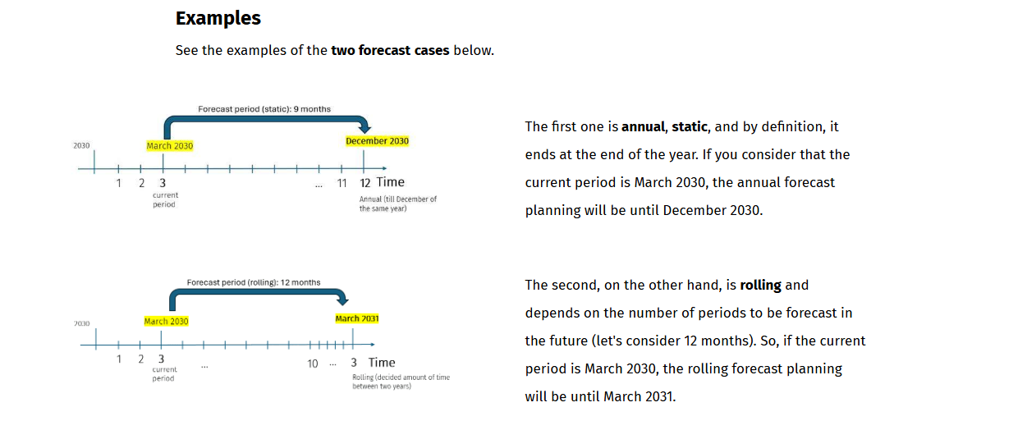

Concepts recap
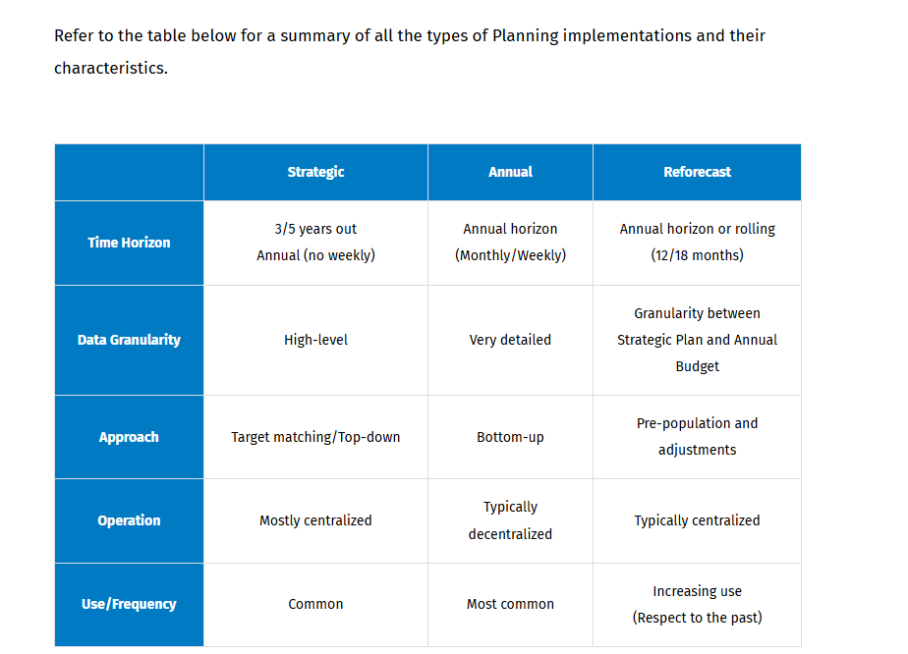

Budgeting methods
A budget is an estimate of income and expenditure for a set period of time. It is a plan you write down to decide how you will spend your money each month. You can picture it, as a roadmap, showing where a company aims to go.
Depending on the size and activities of an organization, you can implement different Budgeting methods.
Budgeting methods are systematic approaches used by businesses to allocate financial resources and help determine how much to spend on different activities. It is the process of operationalization of the financial plan.

There are three main budgeting methods:
- Incremental This method involves adjusting last year’s budget by adding or subtracting a percentage to arrive at the current year's budget. It is based on making small changes and is the most common type of budget due to its simplicity. Incremental budgeting is appropriate when the main cost drivers remain consistent from year to year. However, it might perpetuate some inefficiencies, or lead to budget deficits, or ignore external drivers of activity.
- Zero based : Start from Scratch each year. This method is very tight and avoids any expenditure that is not considered absolutely essential to the business. This type of bottom-up budgeting can be highly effective when there is an urgent need for cost containment. Every single expense must be justified, and no expenditure is automatically approved. Very time consuming approach.
- Activity based : Link the specific activities to their respective costs. It is a top-down type of budget approach where the company first identifies the necessary activities to achieve the objective and then identifies the costs of carrying out such activities. It could improve resource allocation and help cut costs. However, it can be costly and time-consuming.

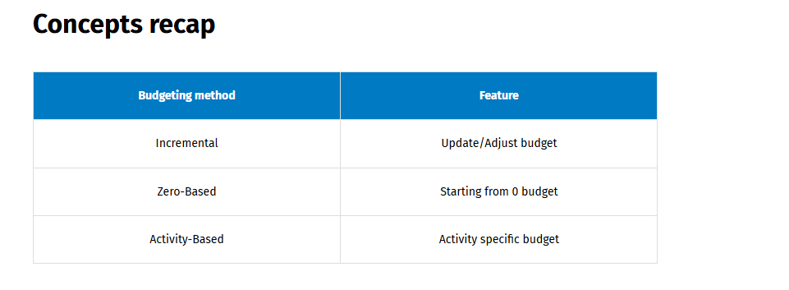

Planning in CCH Tagetik
The implementation of the planning process with Tagetik aims to align all the functions of the company in a unified vision and to connect finance and operations to drive profitable growth
CCH Tagetik offers a variety of tools and solutions to implement planning processes in a unified platform that manages financial and operational information together, allowing you to gain key insights and to make better decisions faster.
In the following framework, you find some guidance on implementing planning processes on Analytic Information Hub (AIH) and on Financial Workspace.
Analytical Workspace :
It offers incomparable flexibility and power with the following features:
- The management of tailored data models and the availability of different Analytical Workspaces
- Extensive options for creating custom calculations for all specific requirements of any planning process
- The Predictive Planning, powered by Artificial Intelligence (AI), which provide estimates based on Machine Learning
The CCH Analytic Information Hub can be used stand-alone or as a data source to serve all your financial management purposes.

Financial workspace(FW)
Even though it is less common to manage a planning process on Financial Workspace, you can always refer to the built-in planning tools that Financial Workspace offers, such as Asset depreciation or Financial allocations.
You can implement planning on the Financial Workspace when you have to perform the following activities:
- Compare figures of different scenarios at aggregated level, for example analyse budget data versus financial close data saved on actual scenario.Budget VS reel
- Implement budget consolidation, namely collect budget figures and consolidate them to have a comprehensive view at group level.—Make Consolidation on Budget
- Use the built-in tool for Cash Flow Planning, which allows you to perform cash flow projections, use direct cash flow drivers to create accurate balance sheets, build realistic cash flow plans and manage cash effectively, reducing financial risk and improving liquidity. – Cash flow planning is needed in the FW.
- Implement a strategic plan, with low granularity and low level of details, for example a plan defined just at account level – Low level of detail planning

Dataset Classification recap
AIH provdied different kind of dataset whose features adapt to different purposes. The selection process should be guided by the specific fatures and advantages of each dataset.
Recommendations on their uses :
- Standard datsets A standard dataset is a fact table, which stores data in physical partitions.
  - You can use it for data entry with a form or QDL.
  - It can be a DTP target because it allows the use of typologies.
  - You can create forms based on its structure.
- Reference dataset : considered as a calculation tool, to manipulate data in a DTP. It can hold global assumptions as coefficients and percentages
- Datasource It is a view of data based on a query that allows you to read data from any table. Data are retrieved on the fly on the time which the query is run.
You can use it for data preparation, especially when the necessary data is not available in the workspace or to create forms that hold data not retrievable from datasets.
- Virtual dataset : It is a view based on joining fields from different datasets. Data retrieved on the fly depending on when the virtual dataset is run.It is useful for preparing data and performing preliminary calculations, as well as creating forms and loading its data in the Financial Workspace.

Knowledge check

Budgeting Planing and forecating 1 – Business Case

Introduction
This business case serves as a reference to the most common approaches in revenue planning, operating expenses (opex), and capital expenditure (capex) planning. It is a guideline of steps to follow to accomplish the most important parts of a budgeting process.
You can follow the business case from the following points of view:
- The financial point of view, considering the different accounts involved in each step.
- The approach, as different methods are shown for different steps.
- The operations implemented, as every approach is put into practice with different calculations.
You will understand the logic of the different approaches and you can adapt them to your business needs. You will examine the technical aspects of implementing the process on the Analytic Information Hub through complex DTP operations.

Steps
Steps 1: The starting point is the target definition, approached with a Top-down method: the sales annual target is input at aggregated level by Line of Business, and it is then distributed among products using DTP allocations. – based on a total BDG, DTP allocates the amount to among different products.
Step 2: The detailed sales plan to meet the target, input by Sales Reps, is implemented with a Bottom-up method: the annual quantities input is split in the 12 periods based on last actual and the resulting figures can be adjusted and funneled up to higher levels of the organizational hierarchy.
Step 3: The operating costs are implemented with a Driver-based approach. Drivers are applied to plan by account and cost center. You can apply mark up or define manual override to force the budget to a precise amount.
Step 4: The costs of personnel are budgeted by position. For each combination of cost center and job level (grade), it is defined the assumption of an average amount for each cost account. The assumption is applied to the number of employees to calculate the total costs.
Step 5: The capital expenditure (capex) is defined by asset class. Each asset type has got its own amortization plan. Once the purchase of asset has been input, the amortization is applied and amounts flow into the three financial accounts involved: asset purchase, cost of depreciation and depreciation fund.

Business Case recap

Financial view | Approach | Operations
Sales target | Top-down | - Insert aggregated annual target  - Amounts distribution  - Allocations
Sales plan | Bottom-up | - Monthly splitting  - Adjustments
Operating costs | Driver based | - Driver selection  - Mark up application  - Manual override
Personnel costs | Assumptions | - Planning by position  - Apply global assumption
Capital expenditures | Financial impact of assets | - Define amortization logics  - Plan asset purchase  - Assess the impact on financial statement

Budgeting Planing and forecating 1 – Familiarize - Takeaways
Plannning is a managerial process that set objectives and actions, with the goal of optimizing future performance of an organization.
- Key benefits of planning:
- Future : Planning helps to anticipate future uncertainties and to minimize risks
- Funding : Planning aims to ensure/drive capital expenditure towards maximum pfitability
- Efficiency : Planning seeks to increase production efficiency control, costs and set accountability
Three types of planning implementations :
- Strategic plan
- Annual plan
- Forecasting/reforecasting

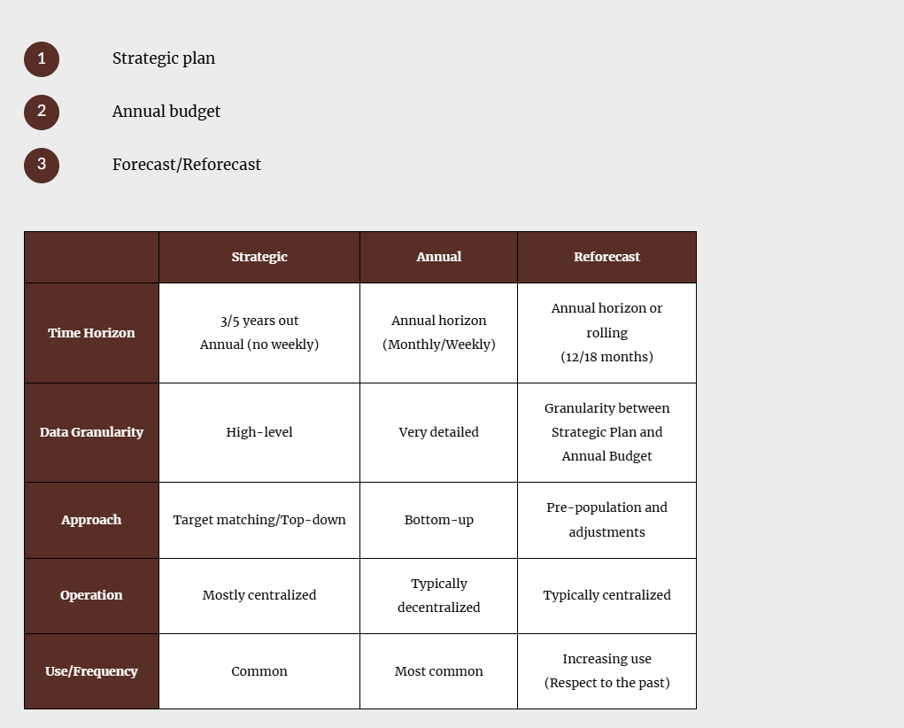

Budgeting methods :
    - Incremental
    - Zero bases
    - Activity bases
Planning in CCH Tagetik :
- AIH or FW are used to make planning
- AIH is preferred for planning
- FW only used for simple planning tools (ex conso budget, …) takes advantages of built in planning tools

Budgeting, planning and forecasting – Top down

Learnings objectives
- What a top down planning approach is
- Which are the tools available for distributing amounts in CCH Tagetik
- How to use DTP allocations to implement a to down planning

Top – down planning approach definition
Definition : Top down planning approachis a method in which planning begins with senior management defining strategic objectives at a high level
Aggregate goals are broken down into specific actions and goals and detailed down through the organizational hierarchy.
This is an approach that usually relies on vision and broad assumptions.
Starting with a broad overview and then cascading down to the lower levels, top-down planning ensures that the plans are coherent and consistent with the organization’s purpose and strategy. It enhances the alignment of all departments with company goals, guaranteeing efficiency and effectiveness of the planning process.

Tools for distributing amounts
The main theme of top-down planning is how to detail down the overall goals and how to break down the aggregate amounts.
CCH Tagetik allows you to implement an amount distribution with several tools. The choice of the tool to use depends on the following aspects:
    - Operations : The type of operations : Some tools are specifically designed for a certain types of amount distribution, e.g. monthly splitting, whereas other tools can be used for a variety of operations such as DTP. Before resorting to a generic tool check whether the specific tool is usable for the purpose.
    - Dimensions : Different dimensions have different possibilities, for example analytical dimensions are not available on Financial Workspace and DTP allocations do not allow to distribute amounts across scenario, period and entity.
    - Workspaces : Analytical Information Hub and Financial workspace have different calculation options. The Financial workspace includes a range of built-in data processing such as Monthly splitting or Financial allocations that are easy to configure or out-of-the-box but may not be adaptable to specific requirements.
    - User interfaces The tools available in Excel data entry mode allow you to process data retrieved in the form, for example with the spreading, whereas from the process cockpit, it is possible to process data in a massive way with other tools, for example Financial allocations.
In any case, it is possible to trigger data processing from Excel, for example running a DTP when saving a form.
You should also keep in mind some exceptions: you can spread amounts using financial reporting tools such as Spreading and Break back on reference element that are available in both Analytical and Financial workspaces. However, you can use proportional Break back only in matrices based on FW.
Finally, in Analytical Information Hub, DTP is a calculation resource with extensive customization options. You can implement any method such as monthly splitting, break back with DTP operation or take advantage of the specific operation DTP Allocations.

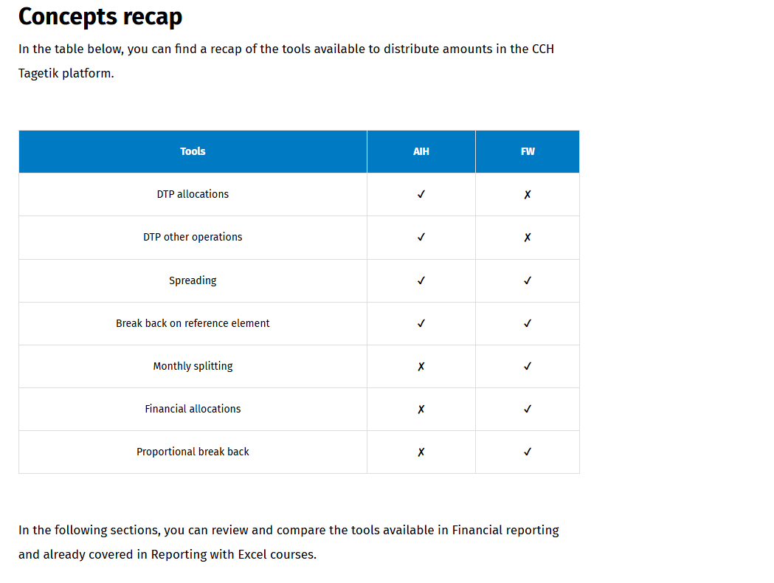

Spreading
Spreading is available in de forms. This feature enable to perform large scale data collection by allowing you to enter a formula cell and distribute it across the cells that are referred to the formula
Typically, a formula cell is not editable in data entry form, but once the spreading function is enabled, the cell becomes editable.
This is the tool you should use to make quick adjustments, at an aggregate level, and spreading the effects across all the components of the total.
In the image below, you can see an example of a matrix where the cells related to operands are editable, while the Total cell is not editable. If you enable Spreading, you can change the result of the formula and spread the difference on all the elements of the formula.
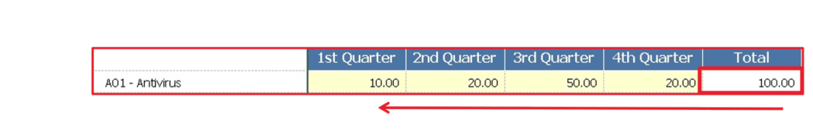

Spreading methods :
  - Proportional :the existing amount are used as weights to spread the formula result
  - Flat : Amount are distributed uniformly across each formula element
  - Seasonality pattern : This method uses fixed weight defined by a sequence of numbers applicable to each month of a quarter 445,454,544 or custom
  - Based ona different Scenario: This option allows you to use the amounts retrieved from a different scenario as weights. For instance, it can use the figures from last actual data or last budget.

Break back on AIH
Break back is a typical tool used for distributing amounts in top down planning. It allows you to enter data at hierarchy node level in data entry forms
On AIH multidimensional matrices, the break back feature is always enabled for Custom Dimensions, Analytical dimensions, Entities, Accounts.
Data is input on Excel cells that represent a hierarchical node, then the value is stored in a specific element belonging to the node, called Reference element.
It is mandatory to define the reference element in each hierarchy node where data is inserted.

Spreadin vs Break back
- No configuration is needed to use either Spreading or Break back.
- Spreading is enabled only by contribution user while breakback is always active on AIH
- Spreading :
  - Data entry : Spreading uses formula cells as source and spreak the value through formula elements
  - Pro and cons: very flexible but does not keep track of amount spread
- Break back
  - Break back involves inserting amount on cells referring to hierarchy nodes. The result will be allocated entirely the the hierarchy node reference element.
  - Collecting data with Break back gives you the impression of inserting amounts on hierarchy node, but it only allocates data in a single element, making it not a real distribution tool.
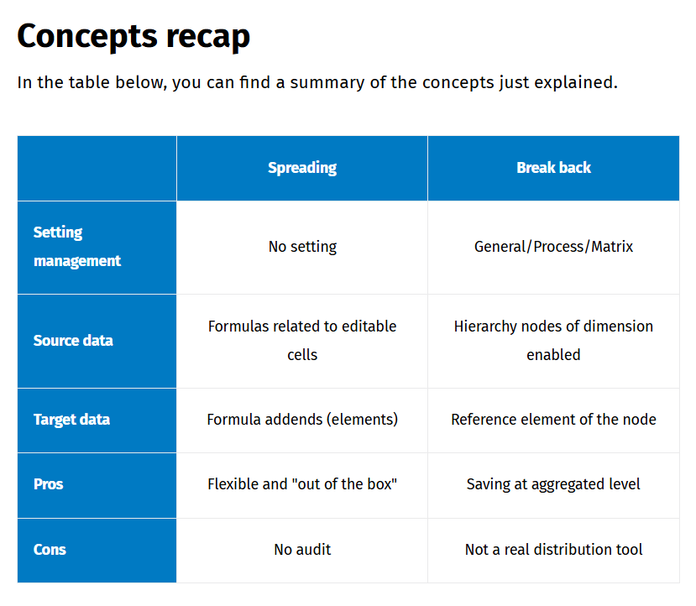

DTP Allocations
Allocation is a process that distributes amounts : a value stored on a generic dimensional element is assigned to multiple specific elements. Allocations also distribute top down adjustment value across other dimensions.
For example, you can use allocations to charge expenses to different cost centers or assign resources (financial, assets, human) to support organization goals.
Below are some of the Allocation Basic Terms, along with their corresponding translations in CCH Tagetik terminology within the DTP allocations operation:
- Sender : The send represents the starting data with the amount stored at aggregated level that needs to be distributed by the allocation. In the DTP operation, you must set sender information as “Data to be allocated/
- Driver : The driver definition specifies how the system should distribute the source data across the destinations. The information si a measure that includes all the weights and details of the desired distribution across the required dimension and can be either financial or non financial. In the DTP Allocation must use the measure as driver. Actual sales figures as an example of financial driver while headcount represents an example of non financial driver
- Receiver: Destination element of the allocation. The driver is applied to the send and the allocation result is saved on receiver. In the DTP operation you choose the dimension on which to distribute the data to allocate, using “Allocate on” , the information of the receiver is stored on a target dataset.
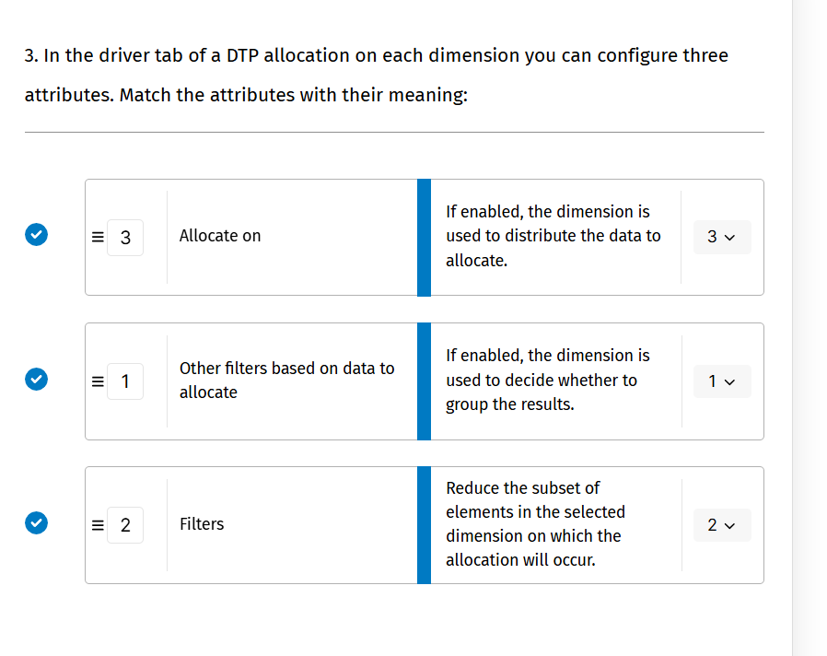
Structure :
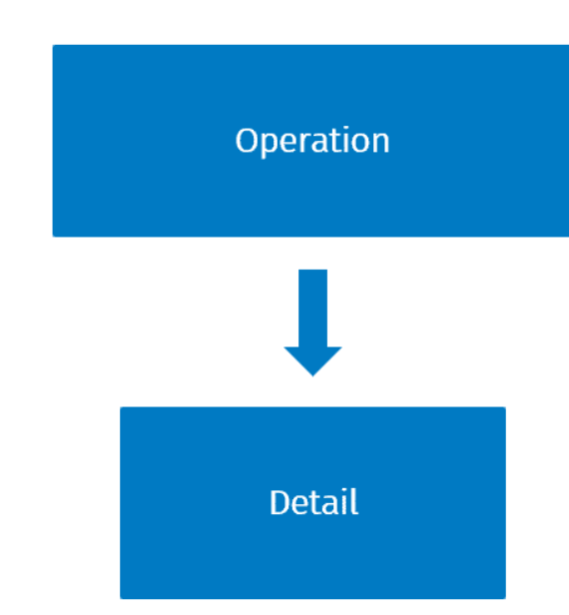
Operation tab : it mus be specified dataset that include :
- Driver
- Data to be allocated
In the detail section you set :
- Measure to allocate
- Driver measure
- Dimension on which the allocation will be based

Allocations examples
Example 1
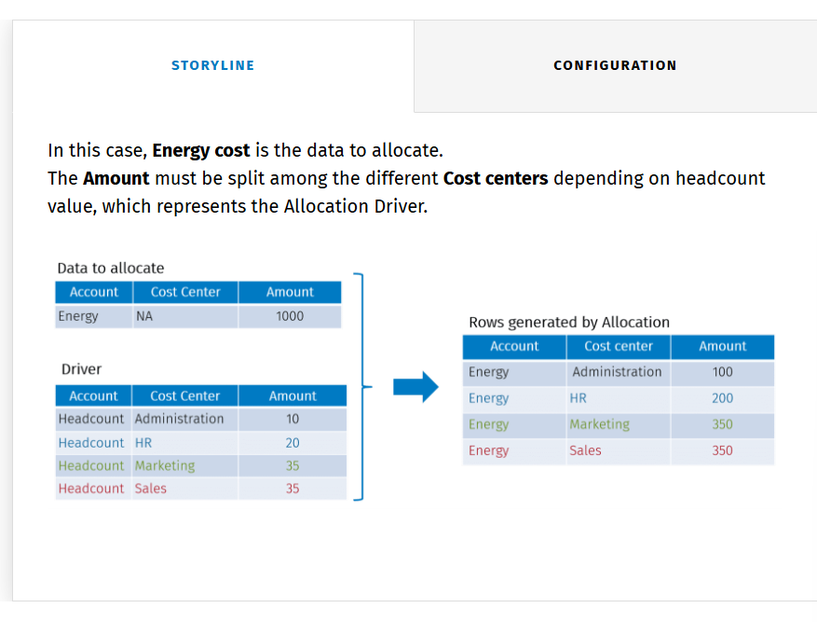
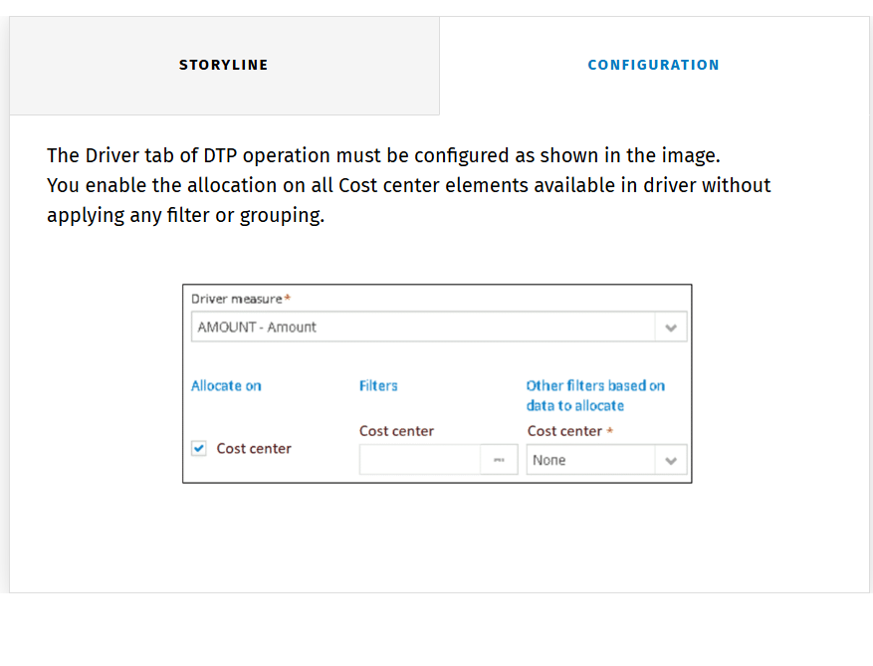
Example 2
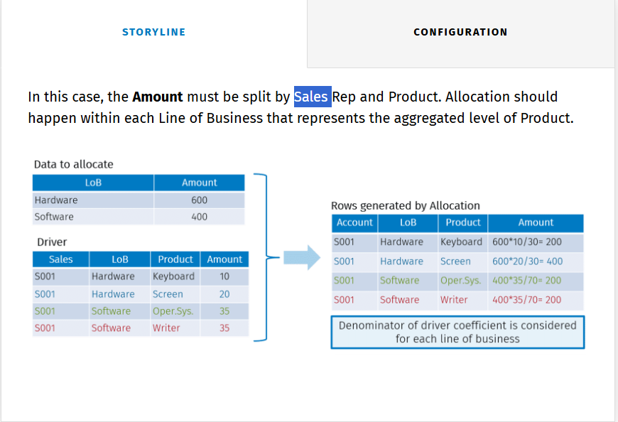
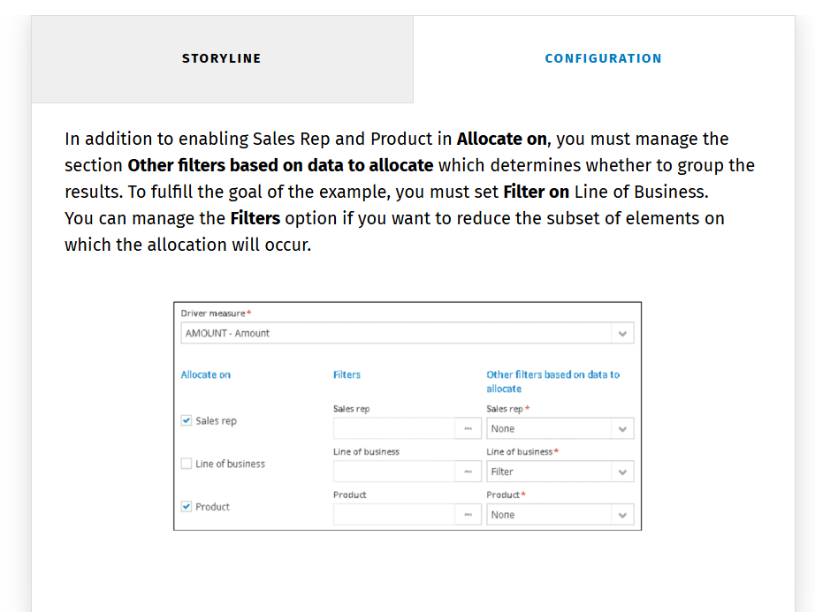

DTP allocations : Restrictions and suggestions
When you have to use the DTP allocations operation you need to take into account some restrictions and suggestions :
- Restriction on target measure: The DTP allocations feature permits the allocation of only one measure in the single operation
- Suggestion on dataset field naming:
  - The absence of matching field hyperlink in the operation implies specific fields coding of datset used for calculation
    - The receiver amount field must correspond with the code of the sended amount field
    - Receiver dimensions are copied from driver datset fields with the same dimensional type
    - All other dimensions are copied from sender fields with the same dimensional type
    - All other measures are copied from sender fields with the same code
  - This means that the name of datset fields must be precisely defined and checked before proceeding with the configuration.
- Suggestion on allocations across Scenario, period, entity:
  - You must apply workarounds when you need to allocate or read driver across Scenario, Period, and Entity. If you need to allocate on them, it is advisable to manage on other dimensions. For instance, you can create an analytical dimension representing Scenario.
  - If driver data is stored on Scenario, Period, or Entity different from the running context, before running allocation, you must transform driver data properly. For example, the allocation must be performed on 2059BDG while driver data is stored on 2058ACT. You need to transform driver data to replace its data with the target Scenario 2059BD

Dimensions representing hierarchy nodes

When you need to manage aggregations of a dimension with many elements, you can create another dimension that represents hierarchy nodes.

This technical tip is useful in the following cases:
In reporting
Running data selecting dimensional elements which represent aggregation is more efficient than having the reporting engine to calculate aggregation on-the-fly.
For calculations
Hierarchy nodes cannot be used as join field on datasets. Additionally, you can use the dimension to aggregate data in DTP calculation and datasets (Data entry on nodes or virtual dataset).

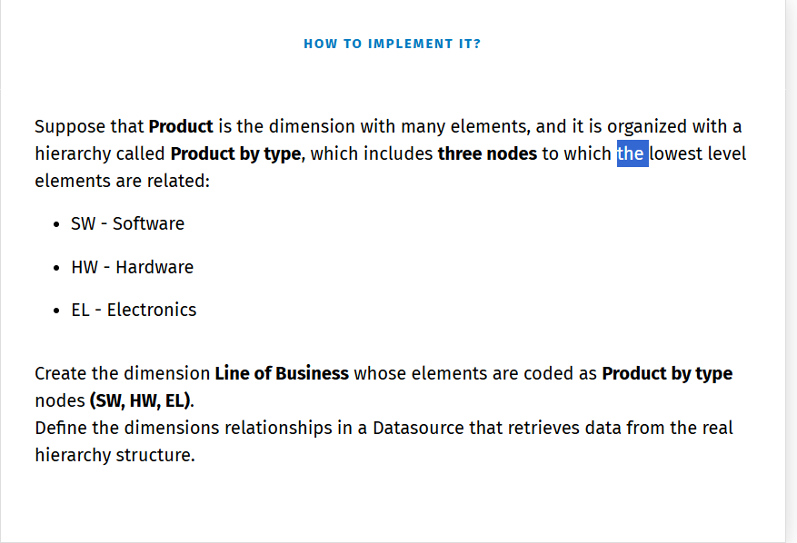

Knowledge check

Business case ;
Imagine that your company defines a sales target by Entity and Line of business. The target amount must be broken down and assigned to Sales Rep and Product.
This process involves assigning an Annual Sales target to an aggregated level (Line of business) and spread the target to the lowest level among Product as required by Top-down planning.
In this business case assume that:

- Currency is not managed
- Line of Business dimension represents the aggregated level of dimension Product

Workflow components :
The Sales target workflow involves:
- Using a datasource to retrieve and prepare data to process
- Managing hierarchy nodes and lowest level elements through different dimensions
- Splitting data across dimensions using DTP Allocations
The schema below shows datasets involved in the calculation. Click on each button to learn more about them.

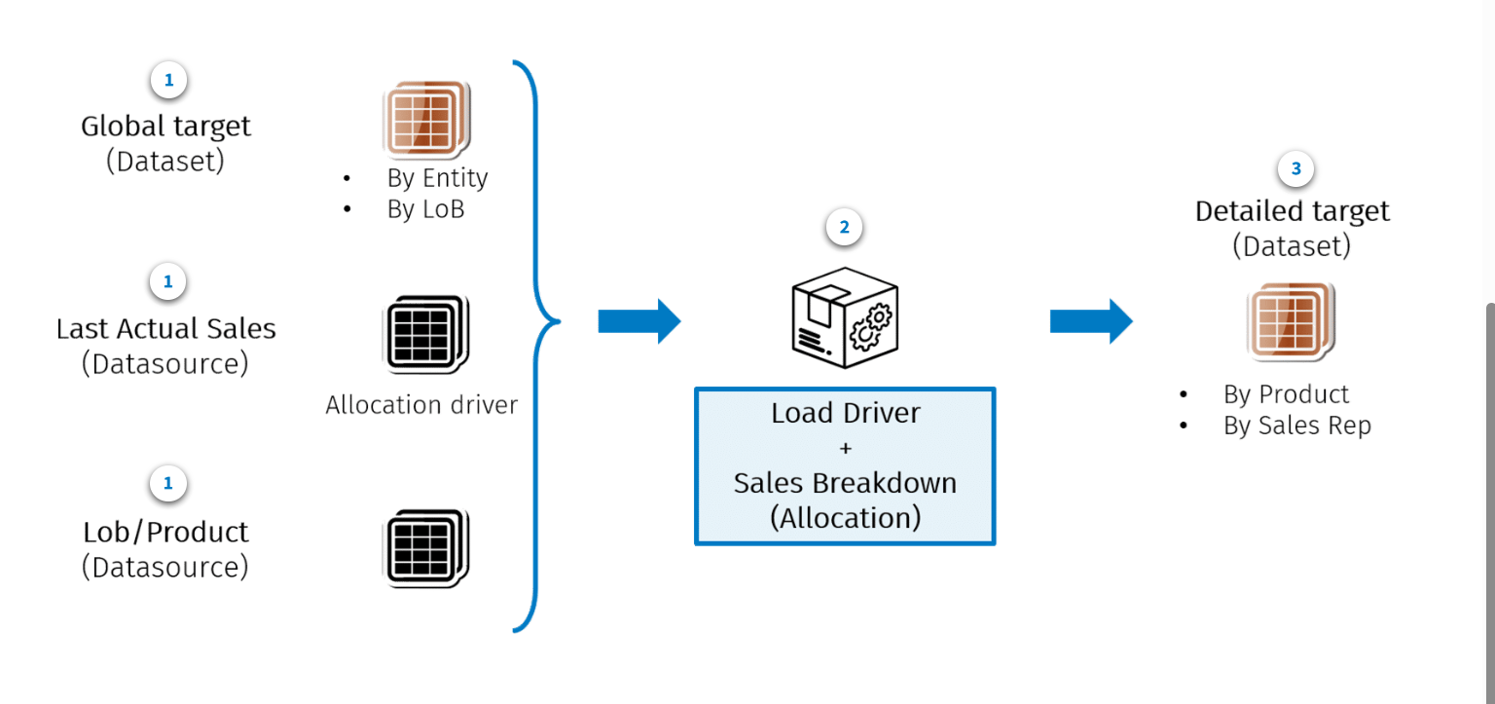

- It is a standard dataset where targets are loaded by data entry. It holds the sales data to be allocated.
- Last Actual sales : It is a datasource used to retrieve actual data from a different workspace. Its data will be used to drive the sales breakdown in an allocation operation.
- Lob/product: It holds the relationship between Line of Business and Product (Lowest level of LoB).
- DTP Activities :
  - Loading driver data
  - Performing allocation operation for sales breakdown
- Data stored un detailes target dataset

Have the following dataset in the environment:
- Global Target datset 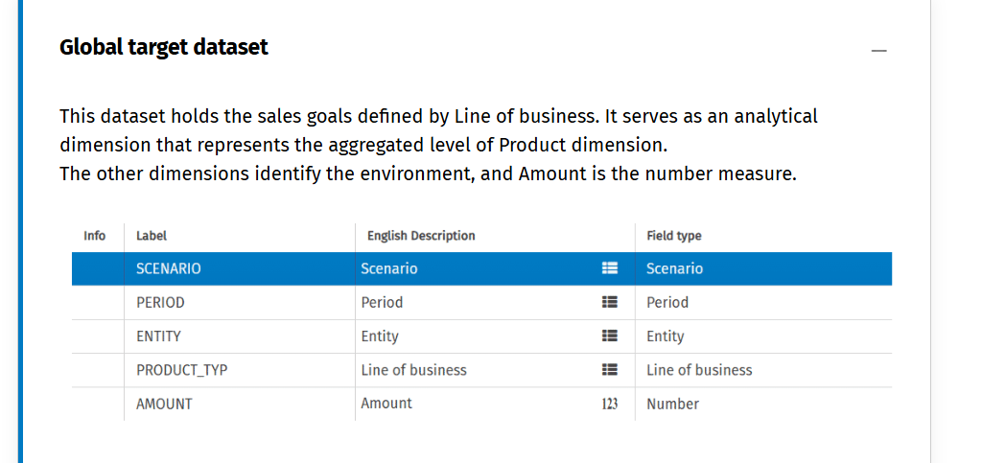
- Detailed target 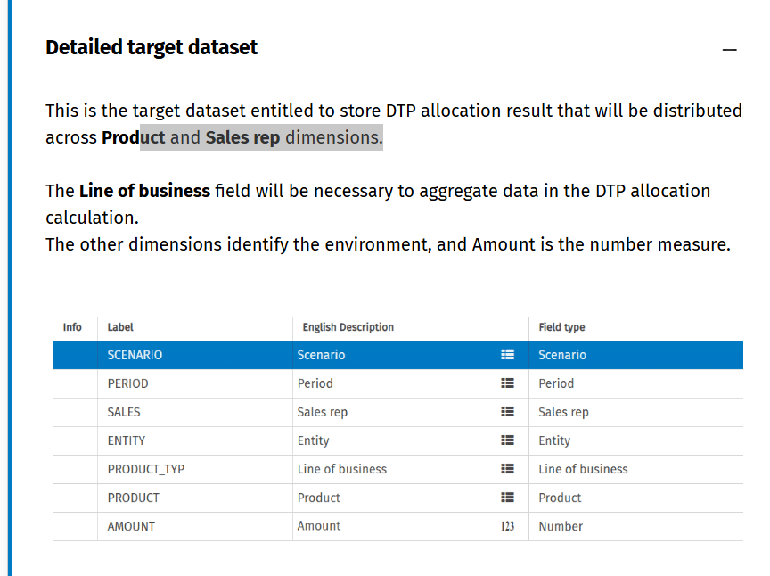
- Product hierarchy datasource:
  - This datsource holds the relationship between line of business and product Actual sales datasource . This datsource is used to retrieve actual sales which are the values used to drive DTP allocations
DTP :
- As two different activities :
  - One to insert the actual driver and add to it the product node.
    - Amount is the measure fields
    - Scenario value is derived from the context
    - The application grouping to reduce process of number of rows.
    - Enrichment to enrich the level of product dimension. Permit to join dataset fields used in the application fields
  - The second activities as a sales breakdowns : use the sales driver grouped in the previous datset.
    - The allocation and target measure have the same level.
    - Filter permit to group result by each line of business
    - Allocates on sales rep and product
- Check the sales report to see the data .

Key takeaways
Top down planning approach :
- Senior management defines high level objectives which are then broken down into specific actions and goals throughout the organizational hierarchy. This ensures coherence and alignment with the organization’s purpose and strategy enhancing efficiency and effectiveness.
Tools for distributing amounts :
- Spreading : Allows quick adjustments at an aggregate level, distributing amounts across formula elements in a data entry form
- Break back : Enables data entry at hierarchy node levels, distributing amounts to specific elements within the node
- DTP Allocations : Distributed valued stored on generic dimensional elements to more specific elements, supporting adjustement across dimensions. Involved defining a sender( data to be allocated), a driver (measure for distribution), and a receiver (destination element). Permit also to apply filters and to group by the allocation result
Dimensuon representing hierarchy nodes : when you need to manage aggregartion of a dimension with many elements you can create another dimension that represents hierarchy nodes. This tip is convenient for these reasons :
- Hierarchy cannot be used as join field on datasets
- Use of aggregation in DTP calculation (allocation) and dataset ( data entry or virtual dataset)

Budgeting, planning and forecasting – Bottom up

Learn objectives
In this module, you will learn:
- What the Bottom-up approach is
- What tools you can consider for implementing bottom-up planning

Bottom up planning approach definition
In bottom up planning, detailed goals are first set at the lower levels of the organization .These goals are then combined into broader objectives as they move up hierarchy.
The bottom-up approach is useful for creating estimates because it starts from the smallest tasks and works up to larger projects. This method is preferred and generally considered reliable when you want to estimate single working processes from the bottom, by steps and deliveries. It is convenient to use when past data of planning and budgeting for similar projects is available, for reference and comparison purposes.
The main theme of bottom-up planning is how to enter detailed data, how to refine and adjust it, before or during the aggregation steps at different levels of the hierarchy of the organization.
CCH Tagetik offers many tools to cover all these operations, which can be classified as follows:
- Tools to distribute amounts
- Tools to adjust amounts
- Tools to aggregate amounts

Tools to distribute amounts
- Amounts distribution can also be perfomed to detail and refine data at the lowest levels.
- In this course, you will see an example of the distribution of amounts across time dimensions: the monthly split. The Financial Workspace has a built-in solution that allows you to define and trigger monthly split logics by account. In the Analytic Information Hub, you can define any monthly split logic through DTP operations.
- Can use the DTP allocation for this also

Tools to adjusts amounts
- After data has been entered, it is often necessary to make adjustments. This can happen at the same level of the hierarchy after an automatic pre-fill or after a calculation, or it can happen at a higher level of the hierarchy, after the data has been aggregated.
- Spreading and break back
- Adjustments can also be implemented in a customized manner in dedicated data entry forms.
- Use a specific dimension to track adjustments

Tools to aggregate amounts
Aggregation is necessary to be able to analyze data at any level of the hierarchy, moving from a detailed view to the big picture.
The primary tool for aggregation is hierarchies, which allow you to associate elements and sum data in any way you want. In particular, the organizational hierarchy of the data collection process also plays a significant role in managing the approval and submission flow. Keep in mind that in the case of groups operating in countries with different currencies, the topic of aggregation is always associated with that of conversion.

Knowledge check

Business Case Sales planning

Learning objectives
- How to implement monthly splitting by DTP operations
- The importance of DTP operations order

Requirements
In the business case, you will focus on data preparation and data processing at the lowest level of the organizational hierarchy.
In the bottom-up workflow, the resulting budgeted amounts at the bottom level will then be progressively aggregated using the tool available in financial reporting and, if necessary, adjusted.
Workflow :
- Step 1: Sales rep have received their annual sales target through the top down approach and have to prepare their salrs budget in detailed manner
- Step 2: Once the sales rep have entered their annual budget, the amounts must be automatically split over the months, based on the monthly weight of the last actual scenario
- Step 3 : The monthly figures calculated can be furter manually adjusted by the sales reps in a de from
- Step 4: At last, the budget data of the different Sales Reps can be added together and at any level of aggregation of the organizational hierarchy they can be analyzed and reviewed in reports.

Workflow components
Sales planning workflow includes the following:
- Using source and target datasets with structures based on calculation and reporting needs.
- Defining a DTP with the operation in the most suitable order to improve calculation efficiency.
- Splitting data through time dimensions with DTP enrichment operations.
The schema below shows datasets involved in the calculation. Click on each button to learn more about them.
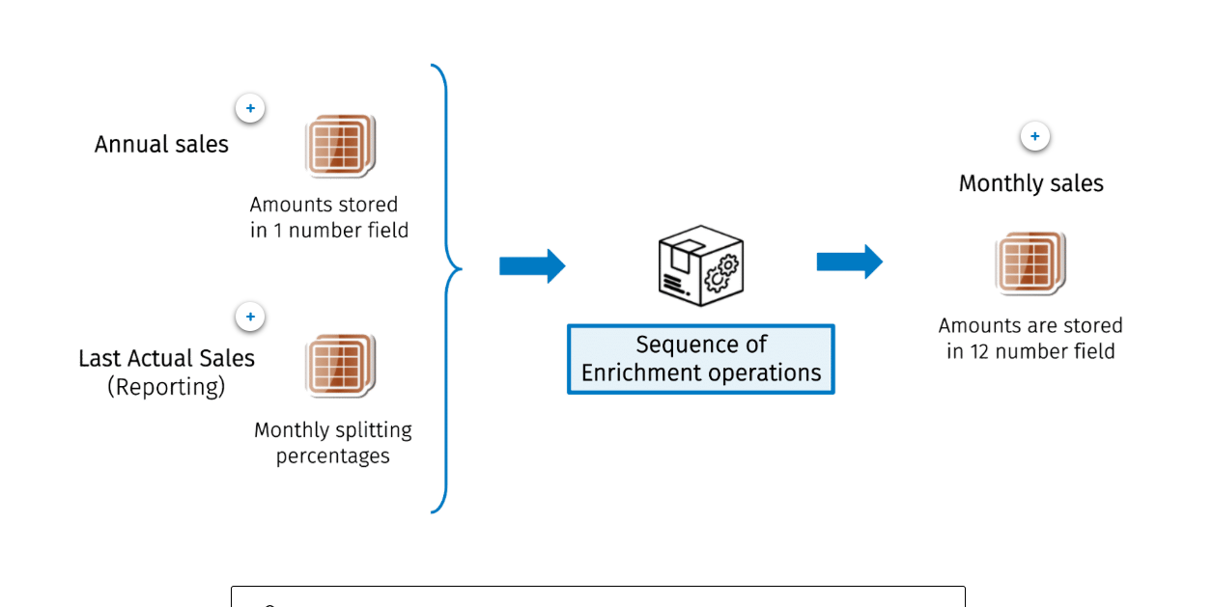
- Source dataset it hodls the amounts to be split. Amounts are stored in a single number field
- Last actual sales contains the previous year’s sales from which you can derive the monthly splitting percentage to apply
- Monthly sales : Amounts are stored in 12 numeric fields one for each of the 12 periods.

Implementation details
The bottom up planning business case environment involves the following dataset :
- Annual sales planning
- This dataset structure includes:
  - Dimensional fields consisting of Scenario, Period, Entity, Sales Rep, Product, and Period
  - Amount is a number measure that represents the Annual sales planning value
  - 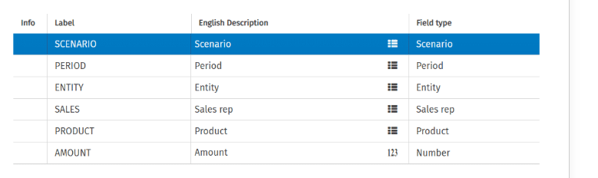
- Monthly sales planning
  - This dataset structure includes:
    - 12 number fields (from P01 to P12) to store the amount of each month. This structure is convenient for:
      - Data entry because it allows you to manipulate a smaller number of rows
      - Simplify calculations
  - Total is a number field that represents the annual total necessary for calculations
  - Dimensional fields such as Scenario, Period, Entity, Sales Rep, and Product.
  - NOTE: Period information is implicit in the 12 number fields. However, the presence of the Period dimensional field is necessary for reporting purposes to create multidimensional matrices. Its value is fixed to "12".
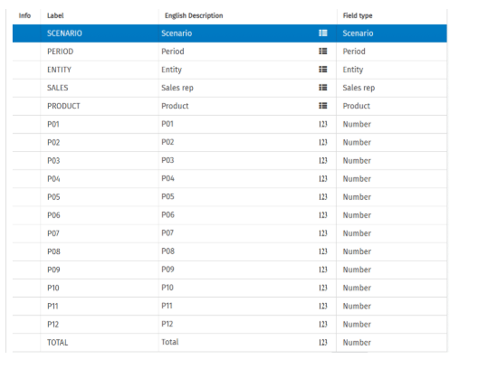

Monthly splitting with DTP operations
Monthly splitting is used when data collection starts with Year amount and you want to spread it over every month. A driver can lead the distribution of the amount. In AIH, it can be implemented using DTP operations.

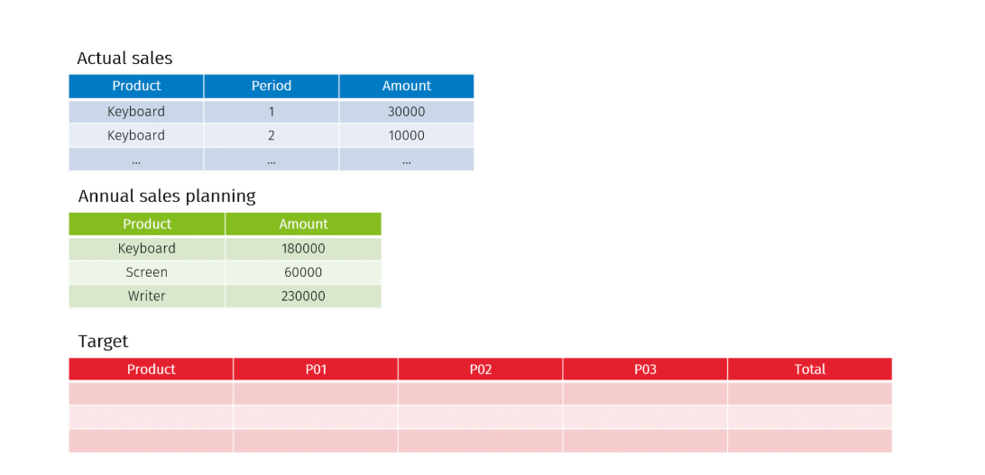

Which dataset should be inserted in the first operation?
The order is relevant both logically and for efficiency. You must first insert the Annual sales planning because all its rows are required, even though the calculation is driven from Last actual sales.
On the contrary, if you start by entering the latest actual sales, you could run into the following errors:
- The inclusion of unnecessary data. For example, those related to products no longer sold.
- The exclusion of necessary data during the operation of enrichment with the annual sales planning. For example, data related to new products being sold.
Consider that, for new products, you do not have monthly percentages from the previous year. In this case, you should provide a rule. For example, a flat spreading or refer to percentages of the same product family.

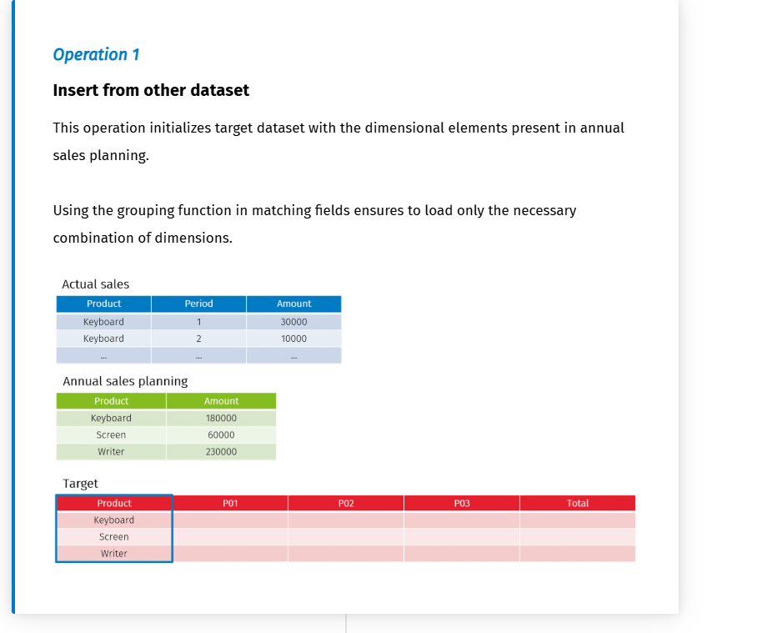
Insert only the data for the corresponding account (only one 1 account here)
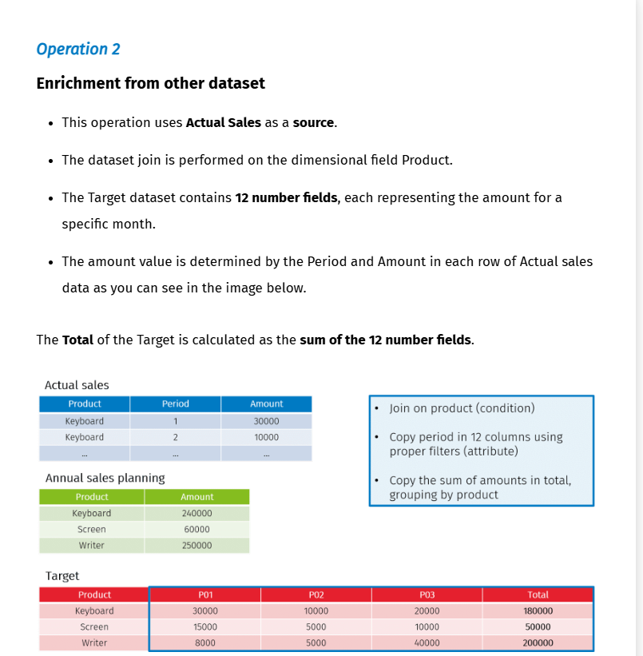
Sum amount, to have the total

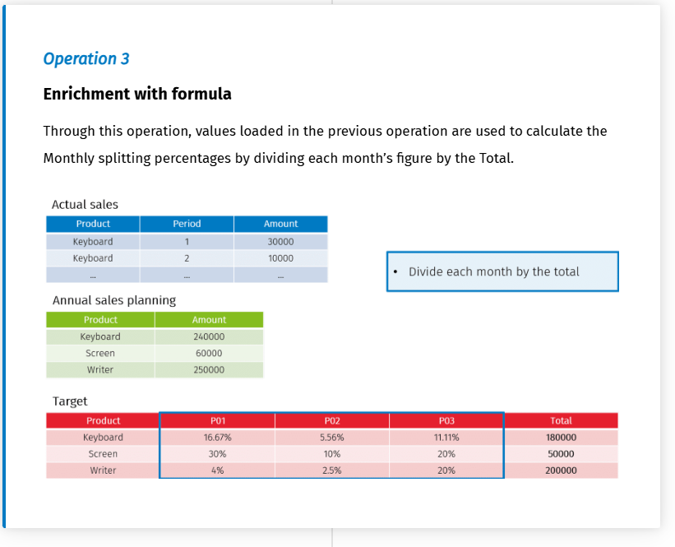
Monthly split %, for each related fields is based on the actual sales. Calculate te repartition of sales across all the period.
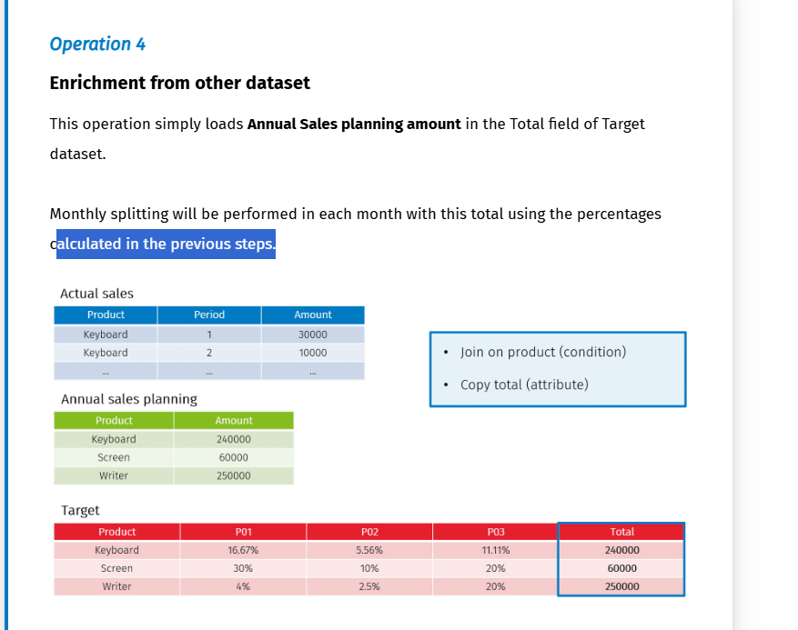
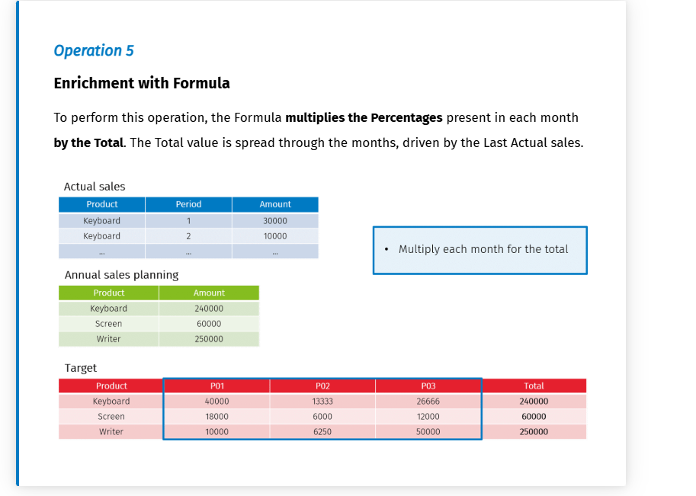

Monthly splitting demos

Bottom-up Planning

This approach involves setting detailed goals at the lower levels of the organization and combining them into broader objectives as they move up the hierarchy. It is useful for creating estimates by starting from the smallest tasks and working up to larger projects.<
Tools for Bottom-up Planning
- •
Distribute Amounts: Refine data at the lowest levels and distribute amounts across dimensions with DTP allocations.
- •
Adjust Amounts: Make adjustments at the same level of the hierarchy after an automatic pre-fill or calculation, or at a higher level after data aggregation.
- •
Aggregate Amounts: Analyze data at any level of the hierarchy, moving from a detailed view to the big picture. Hierarchies and currency conversions play a significant role in managing the approval and submission flow.
Business Case Sales Planning
- •
Workflow: Data preparation and processing at the lowest level of the organizational hierarchy, followed by progressive aggregation and adjustments using financial reporting tools.
- •
Sales Representatives: Enter their annual budget, which is then automatically split over the months based on the monthly weights of the last actual scenario. The monthly figures can be further manually adjusted by the sales reps in a data entry form.
Go to next step(disabled until content is completed)(disabled since this is the last step)Restart
Step 4 of 4
Implementation Details
- •
DTP Operations: Define a DTP with operations in the most suitable order to improve calculation efficiency.
- •
Monthly Splitting: Split data through time dimensions with DTP enrichment operations.
- •
Datasets: Use various datasets to store and manipulate amounts

Budgeting, Planning and forecasting 1 – Driver based planning

Learning objectives
In this module, you will learn:
- What Driver-based planning is
- How to use reference type level and wildcard values in a reference dataset

Drivers based planning definition
Definition : Driver-based planning is a method to forecast business performance using a hierarchy of value drivers that are based on strategic objectives specific to the company.
Driver-based planning focuses on identifying the key factors that drive the business and creating a plan based on those drivers.
It allows businesses to forecast outcomes more accurately and make them more responsive to changes by increasing speed, transparency, and efficiency.
Identifying drivers :
- Identifying the appropriate drivers is one of the biggest challenges when implementing driver-based planning
- This process requires understanding the factors and the relationships that influence reenues and costs
- Comprehending the nature of the business and the types of costs involved plays a significant role in determining the suitable drivers
Outcomes: Understand how the key drivers produce actionable outcomes and results is essential.
Data sources, availability, and quality are crucial for research. Machine learning can provide valuable insights.

Tools to apply drivers
Often key drivers have a different and more general dimensional detail than the data to which they are applied.
The most important issue to be resolved when defining a driver-based planning on CCH Tagetik is how to specify the drivers and how to match their dimensionality to the business data.
In the Financial Workspace, typically, both business data and driver lay on the gross original amount table, and drivers can be applied using multidimensional script (MDX) to match the dimensions and calculate the planning.
In the Analytical Information Hub, the reference datasets offer capabilities to help define drivers and apply them within a data transformation process. The exact combination of dimensions to match must be carefully defined via the condition fields.
NOTE: For details about Reference datasets, refer to the Data Integration with DTP course.
In this course, some more features are covered: the reference type level, wildcard values, and drop-down list for data entry.

Reference type level in reference dataset
A reference dataset can be used for implementing driver based planning it allows for storing and applying planning definitions rules.
A reference dataset is a dataset that acts as a lookup table. Data mapping is performed between the elements of input fields and output fields
The purpose of the fields is defined through an attribute called reference type
  - The value for an input field is Condition
  - For an output field : Attribute
- Level and Filters are addition references types used for advanced purposes:
  - Level : The purpose of using a level reference types is to define a level fo exception to a behavior defined in the source dataset. Level is a reference type that can only be assigned to a numeric field. A Higher level value indicates higher priority. In the definition approach, general rules must have a lower value in the level fieldsccildcard caracter such as % can be used to apply concise defiinitions
  - Filter: With the reference type filter, you write in SQL, a syntax to filter the target dataset in the data writing or updating step In short, with the filter you can apply or not apply the data transformation row by row.

Example :
Storyline :
Imagine that for a product, you want to define the same price for all of Italy, except for one region. In this case, the synthetic definition with wildcard and by priority and exceptions with levels allows you to avoid defining the price for each region.
This example shows how to enrich the target dataset with Price based on the Region.
Reference types values :
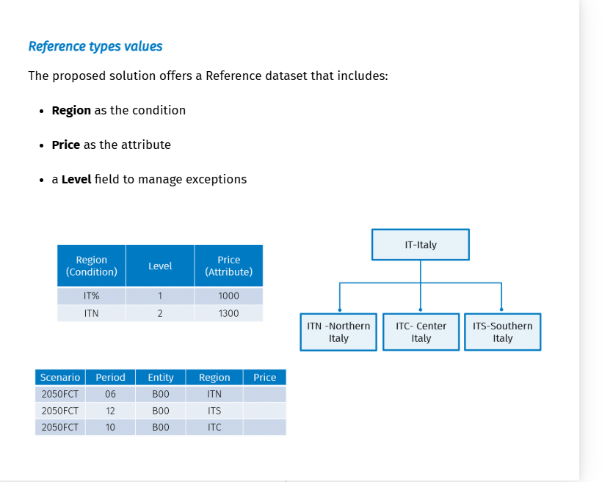

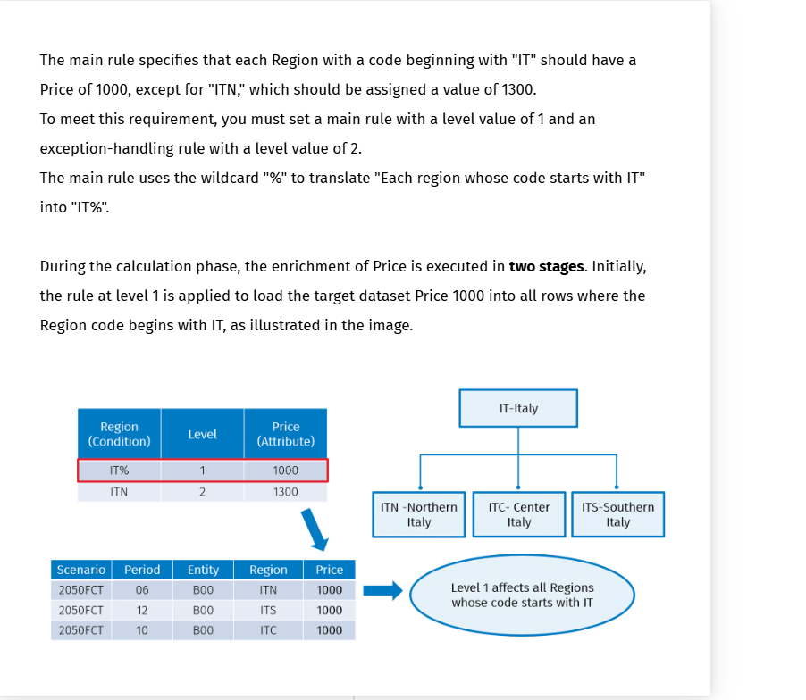
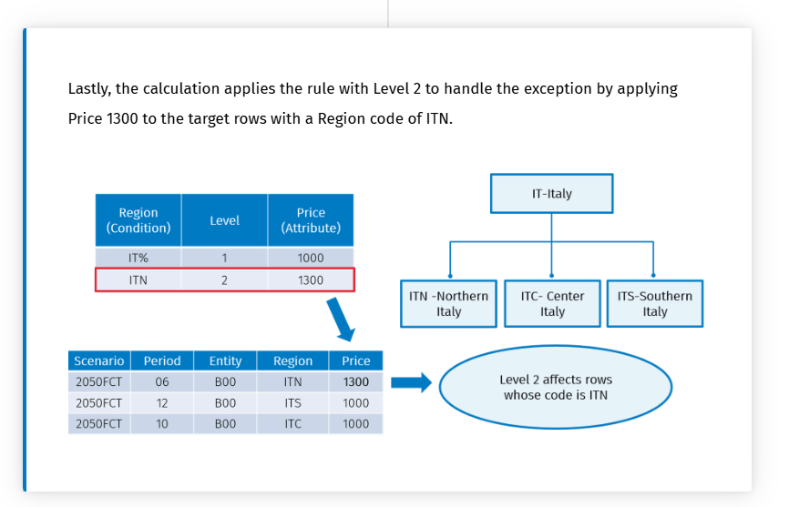

Pro tip How to collect wildcard values n a field restricted by a drop down list

Wildcard values are designed to permit sunthetic definitions in a reference dataset. However, manually entering such values in a field restricted by a drop down list may present an issue.

Storyline :
Consider a case where you wish to collect the rules that govern your cost planning using a line-by-line data entry form. Consider a field, such as Account, where you intend to apply a concise definition to all elements whose code begins with "503". You will need to enter the value 503% in the corresponding cell.

Isssue : A problem arises if a drop-down list restricts the field values.
Specifically, dimension fields only permit dimensional elements, while text fields with an associated dictionary only allow dictionary elements. Consequently, you are unable to manually enter the value 503%.
How to :
To address this issue, following the instructions below in the given order is recommended:
- In the Reference dataset, designate the field associated with the Account dimension as a text field.
- Associate an appropriate dictionary
- Enable the option "Out of dictionary values allowed"
This configuration will allow users to select values from a drop-down list in the data entry form or overwrite the cell with any value that includes wildcard characters, as illustrated in the image below.

Knowledge check

Business Case driver based planning

Learning Objectives
- How to implement driver based planning with DTP operations
- How to define a reference dataset to apply drivers to business data

Requirements

This business case example will guide you through the implementation of driver-based planning aimed at analyzing operating costs. It is assumed that the drivers are available, and you will learn how to utilize them, implement markups, and conduct manual adjustments.
The cost planning calculation begins with establishing a baseline, which consists of the actual amounts of the previous year.
Budgeted values can be calculated with the following options:
- Using a markup, which involves applying a fixed percentage to the baseline to determine the amount.
- Applying drivers, which involves retrieving the percentages of evolution associated to the drivers and apply them to the baseline to determine the amount.
- Inserting a manual overwrite, in this case, the amount is simply entered with a fixed value.
The baseline data can be identified by account and/or by cost center. A concise definition must be possible, for example, applying the same markup to more accounts starting with the same code.
Driver based implementations is divided into two steps that correspond to distinct exercises:
- Definition of cost planning in a reference dataset
- Performing driver based calculations using FTP operations

Implementation details : Definition of cost planning in a reference dataset

the implementation requires a Reference dataset known as Cost Planning Definition, which contains the rules required to apply to the baseline in order to draft an accurate budget for costs.
The rules definition in the reference dataset takes advantage of the use of dictionaries and wildcards characters to push the application of synthetic definitions.
The dataset structure is illustrated in the image below.
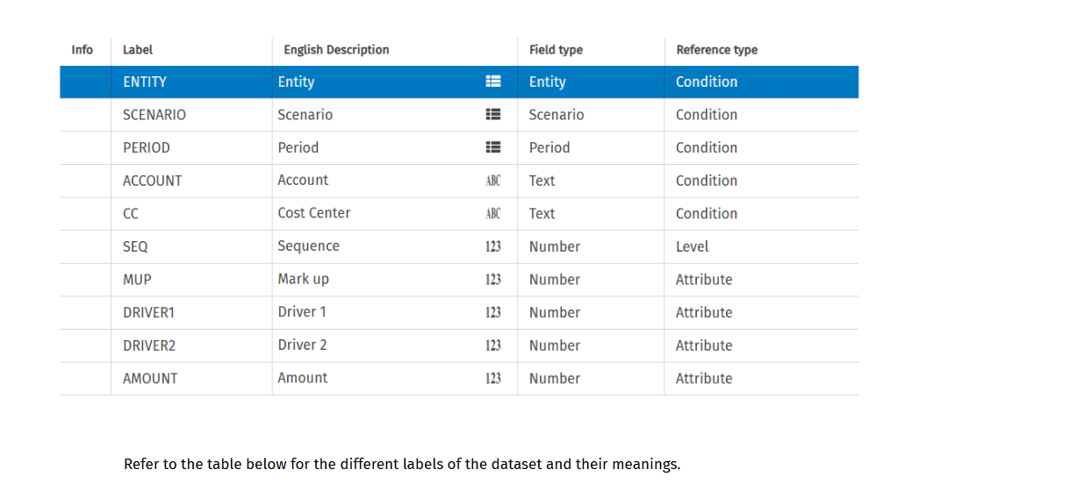
Label field | Meaning
Scenario, Entity, Period | They are dimensional fields used as conditions.
Accounts, Cost Center | They also serve as conditions, but they are text fields with values restricted by two dictionaries.  These fields are used to define drivers that impact the result.
Sequence | It is a numerical field designed to manage the priority of the planning rule applied.
Markup, Driver1, Driver2, Amount | These are four attribute fields employed to influence the result according to the planning rule:  - The First Rule: Calculates the result using the formula Markup × Baseline.  - The Second Rule: Fixes the result calculation with the formula Driver1 × Driver2 × Baseline.  - The Third Rule: Allows for overriding the result with the Amount value.

- Account and Cost center are used with dictionary – Use the Out of dictionary allowed to have the wildcard.
- Two drivers will be added to the baseline
- Amount isa used to overwrite result on the desired dimension
To insert the cost planning rules via a DE form : Line by line matrix related to the Reference dataset. Can have a sequence affected by the driver chosen from the list, the cost planning will be drived by the two drivers. The last exception, is an amount that comes overwrite the amount.

Workflow component

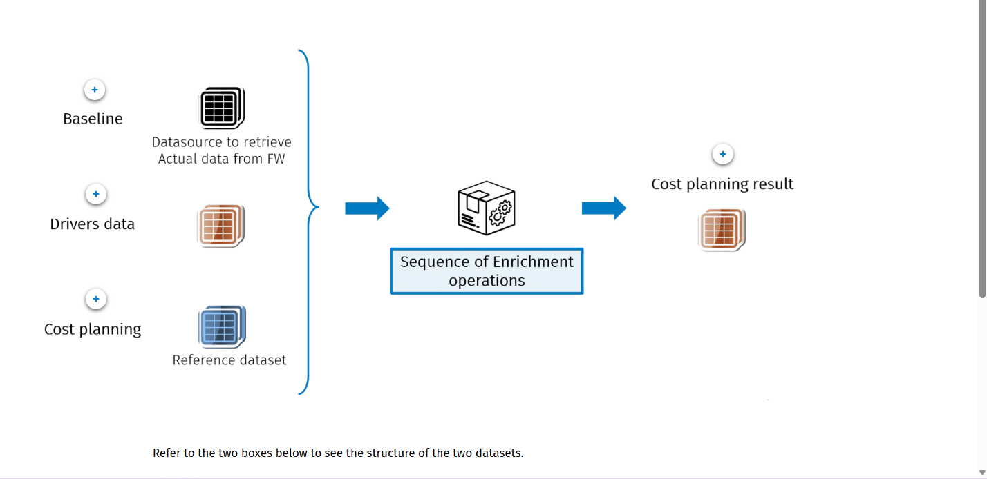

- Baseline : Datasource to retrieve actual data from FW
  - It is a datasource used to retrieve last actual costs from financial workspace
- Driver Data : It is the dataset that stores the list of available drivers and the percentages to apply in the calculations. The dimensions Scenarion and period and cost center identify the driver and related percentage to apply.
- Cost planning : It is the newly created reference dataset that hold cost planning definitions, which will be applied in the driver based implementation
- Cost planning results: This represents the target dataset for calculation. The dimension used to identify the cost predictions included scenario period entity account and cost center. Amount PY sevre As the baseline figure, while markup%,Drivers,and percentages ares essential for calculating the final result which is represented in the amount field.
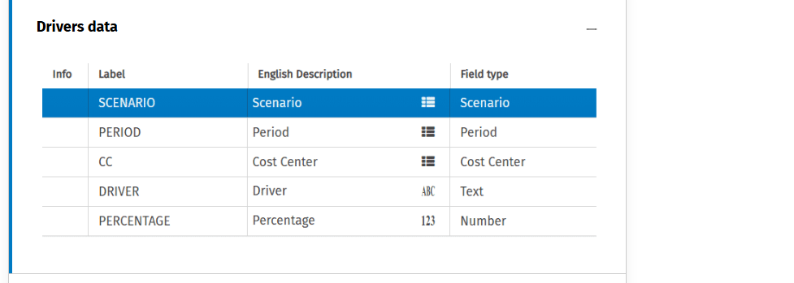
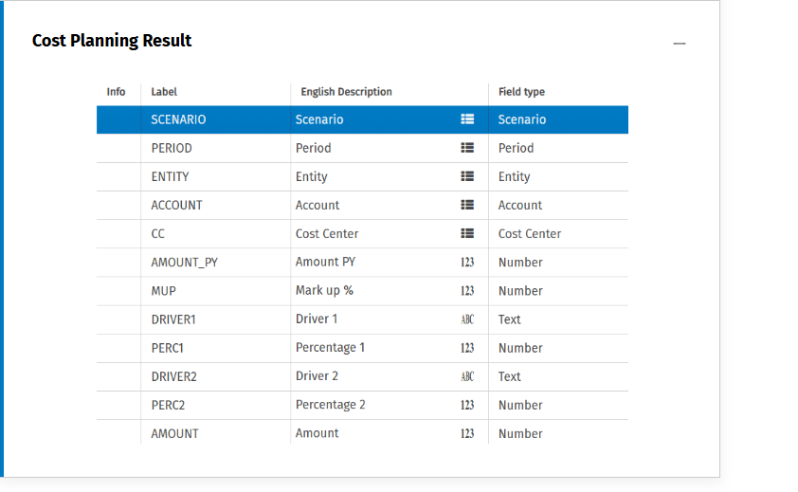

Implementation details : Driver based calculations with DTP

You can implement the driver-based calculation using a Data Transformation Package (DTP). The sequence of DTP operations is important for logical coherence and efficiency. It is necessary to determine which dataset should be inserted in the initial operation.
Which dataset should be inserted first?
You should start by adding the Baseline dataset, which includes the Last actual costs. Every row from the last actual cost dataset is required since they form the baseline.
DTP Sequences :

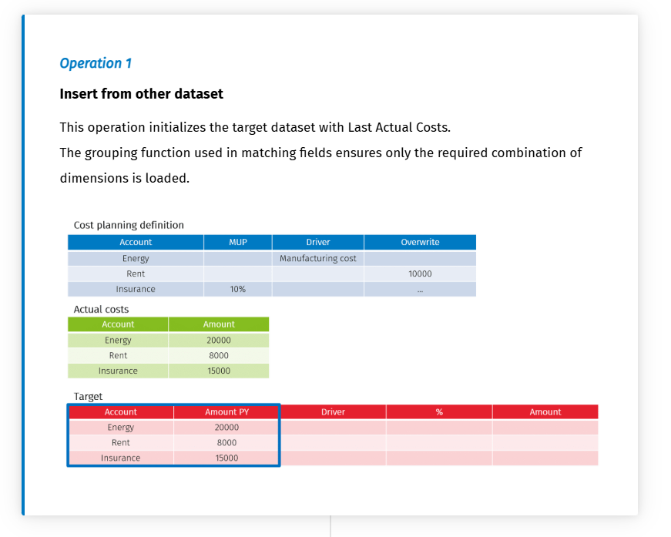
OP1: Insert the local data. Scenario retrieved from the context.

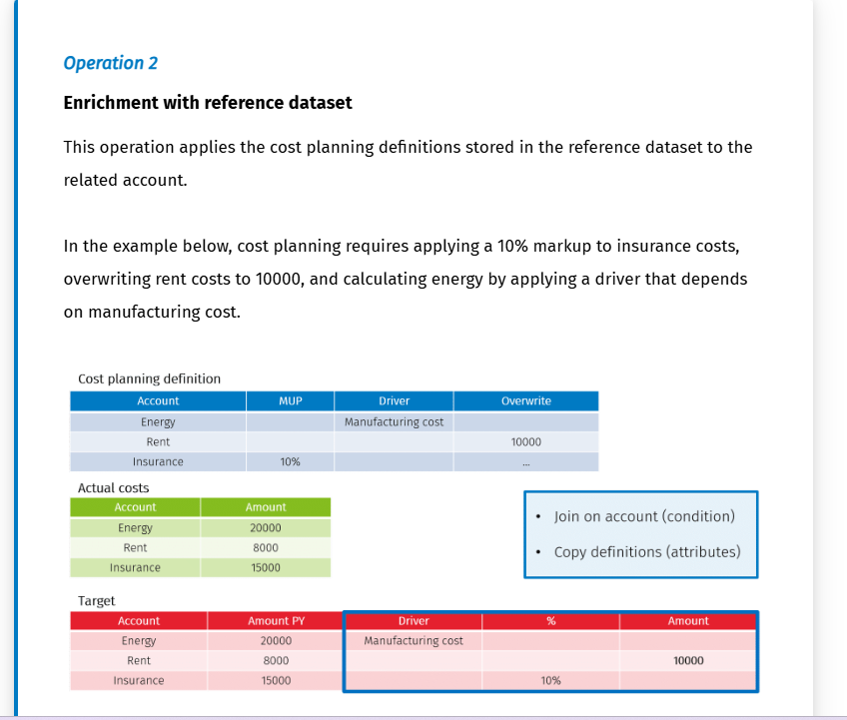
OP2: Load the markup definition, override value

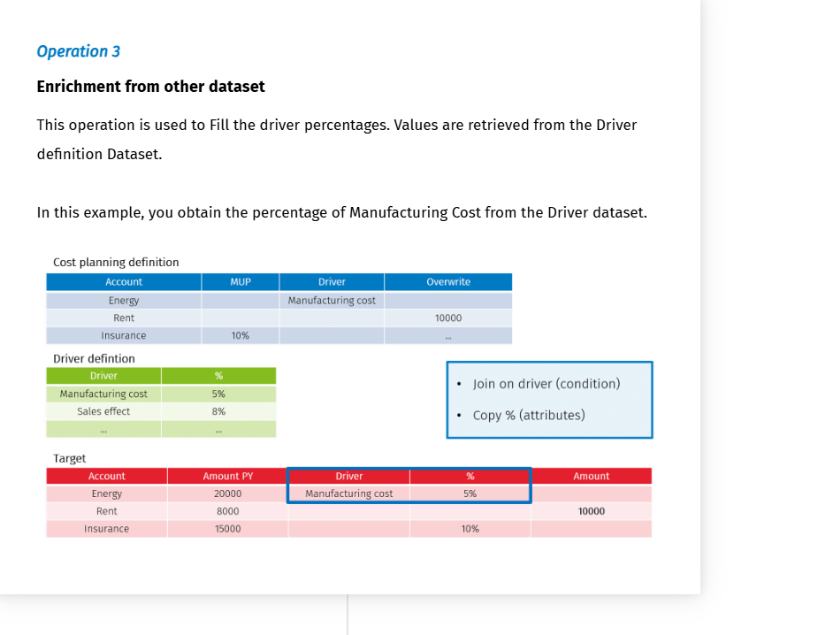
Driver dataset : To retieve the % based on different driver (two dataset join are necessary because have two different types of driver

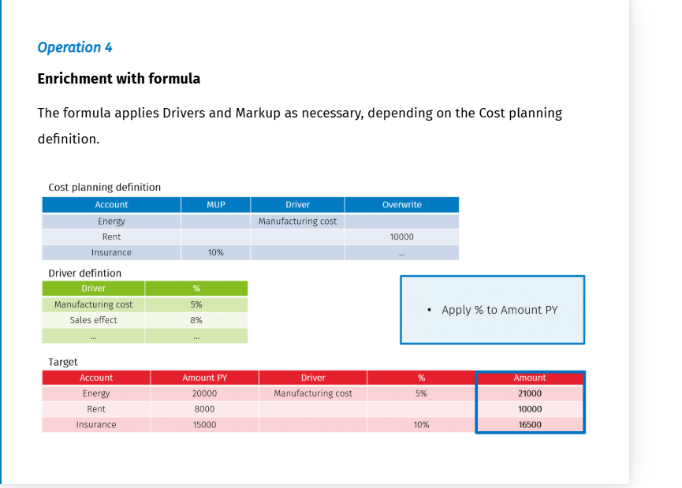

Knowledege checks
Reference datasets play an important role in storing and applying planning definitions, allowing for synthetic rule definitions using wildcards and levels.

Effective management of driver-based planning requires a structured approach to defining and prioritizing rules, handling exceptions, and integrating data from various sources.
Practical applications
Practical application of driver-based planning includes steps like setting baselines, applying markups and drivers, and performing driver-based calculations using Data Transformation Packages (DTP).

Budgeting, planning and forecasting 1 – Assumptions

Learning objectives
Objectives :
- What budgeting with assumptions is
- The tools offered in CCH Tagetik to define assumptions

Assumption Definition
Creating a budget can be simplified using global assumptions
Definitions :
- The assumptions serve as global parameters that guide your business plan, aiming to project current data into future contexts
- Initially set a a high level, they are also applicable to granular levels and can be adjusted to enhance predictive accuracy. It is sufficient to modify an assumption and evaluate its cascading effects.
Companies utilize assumptions to quickly adjust budget, support multiple planning, scenarios, and improve expense management and hirging strategies
Assumption VS Drivers based planning
The difference with driver based planning can be highlighted by the following aspects :
- Static vs Dynamic approach:
  - Assumptions are generally less dynamic and may be updated rarely :
    - Example: If you decide to create the personnel budget by multiplying the average salary by the number of FTEs, this formula is likely to remain consistent over the years. Only the salary and the FTEs will change.
  - Drivers can be updated in real time and reflec market changes.
    - Example: If you decide to create the personnel budget by multiplying the average salary by the number of FTEs, this formula is likely to remain consistent over the years. Only the salary and the FTEs will change.

- Different Focus
  - Assumptions approach tries to predict how revenues and costs change over time, based on historical trends and future expectations.
  - Driver based planning seeks to predict how future performance is influenced by drivers, such as marketing campaigns or employee productivity.

Tools to apply assumptions
The application of assumptions is typically integrated into data processing tasks to minimize manual work and increase efficiency.
For implementation in CCH Tagetik, the tools used for driver-based planning are often also used for planning with global assumptions. For example:
- In Financial Workspace, you can use the multidimensional script (mdx) to perform the calculation.
- In AIH, you can use a DTP to perform calculations and a Reference dataset to define the assumptions.
Assumptions can often be represented by hypotheses about average values that can be applied and deployed to perform calculations on detailed elements of the data model.

It is essential to accurately match the dimensionality of the assumptions and apply them across all the dimensional elements required for budgeting.

Assumption regarding personnel costs : example
The following list includes examples of global assumptions that can be defined to calculate personnel costs:
- Number of hours worked
- Average hourly wage
- Average salary by position
- Number of employees
- Number of Full Time Equivalents (FTE)
- Percentage increase in salary
- Contribution rate
- Tax rates
You can set these parameters to forecast wages and salaries, taxes and employee contributions

Calculation rules definition and application example
The result of the estimation of the personnel costs can be obtained by applying calculation rules derived from the global assumptions.
Based on the data held in the dataset below, you want to calculate Total Wage and Total Contribution by country for each period.
The dataset contains the Headcount value for three periods for each country and includes the assumptions that in this case are Daily wage and Contribution.
The following formulas are required to calculate the Wage and Contribution:
- Wage = Headcount x daily wage x number of working days
- Contribution = Total wage x Contribution%

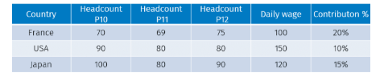

Calculation rules implementation:
- Configure a reference dataset to store the result account and the operands of the calculation rule.
- Create a virtual dataset that joins the input dataset and reference dataset. In this step compose the formuala in the formula fied using the operands stored in the reference dataset. For technical reasons, it might be necessary to join a technical dataset to retrieve fields used in the formula
Once the formula and its value are established a DTP will calculate the amount of the result account.
Reference dataset
It is advisable to utilize a reference dataset to establish the calculation rule, as it serves to store definitions rather than amounts.
Below you can see the reference dataset used for the example.
The general formula you can use to calculate Wage and Contribution is:
Result account = Factor 1 x Working days x Factor 2 x Coefficient
The reference dataset contains various operands in each field along with the result account of the calculation rule.

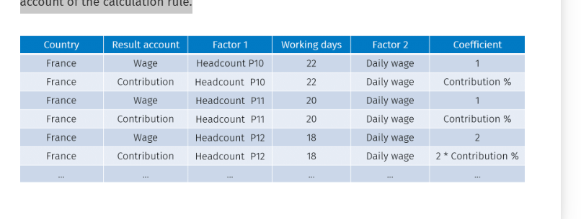
Virtual dataset
It is generated by the join of datasets that store Input data and the reference dataset that holds the calculation rule definition. Here you can define the formula field to store the formula to calculate the Result accounts.
Below you can see an example of a Virtual dataset structure.
When the Result account field is set to Wage or Contribution, the formula in the highlighted field will consist of different factors.
NOTE: The formula includes a coefficient of "2" in rows related to Period 12 because it is assumed that in December, Wages and Contributions are doubled.
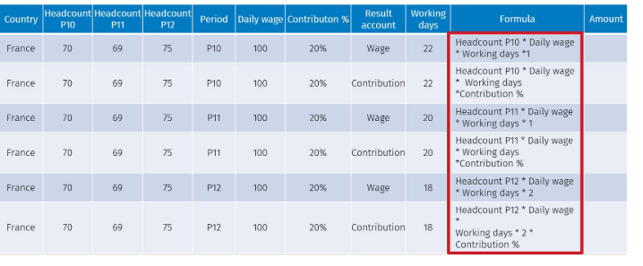

Applying Calculation rules in the financial Worksapce : Calculation Logic

Calculation Logic is a high performance tool for complex calculations. It is the est tool to apply global assumptions in the financial workspace.
It allows you to book the calculation of an algorithm on a result account. There are two types of calculations logic:
- SUM : It allows you to calculate the sum of account but lets you add mak up to addend or apply filters and override dimensions. It does not require scripting language knowledge
- Multidimensional Logic: It requires MDX scripting language knowledge and you can use it to create complex algorithms like reading or writing data from different scenarios/periods

Knowledge check

Business case personnel planning
Will learn :
- How to define assumptions with reference and virtual datasets
- How to apply calculations rules based on assumptions with DTP operations

Requirements
This business case aims to instruct you on how to define and implement calculation rules influenced by global assumptions.
Consider that your company seeks to estimate the annual costs of personnel. To drive your business plan, establish, as global assumptions, the average cost per person for the following accounts based on job grade:
- Monthly Wage
- Contribution
- Bonus
- Benefits
These assumptions must be applied to the number of employees per grade of each period.
You are required to calculate the total amounts for the four accounts mentioned above for each period.
The data must be provided in a structure suitable for generating reports in a financial reporting application.

Worklfow components

The personnel planning workflow includes:
- Using a reference dataset to define assumptions and calculation rules
- Defining a Virtual dataset to retrieve data, join data assumption and calculation rules, and verticalize data
- Prepare the data for processing by utilizing a formula field
DTP operations to apply assumptions using the Enrichment with formula field, unpivot data Group, and delete data using DTP filters and aggregate functions
The schema below shows the datasets involved in the workflow. Click on the buttons over the image to discover more about them.

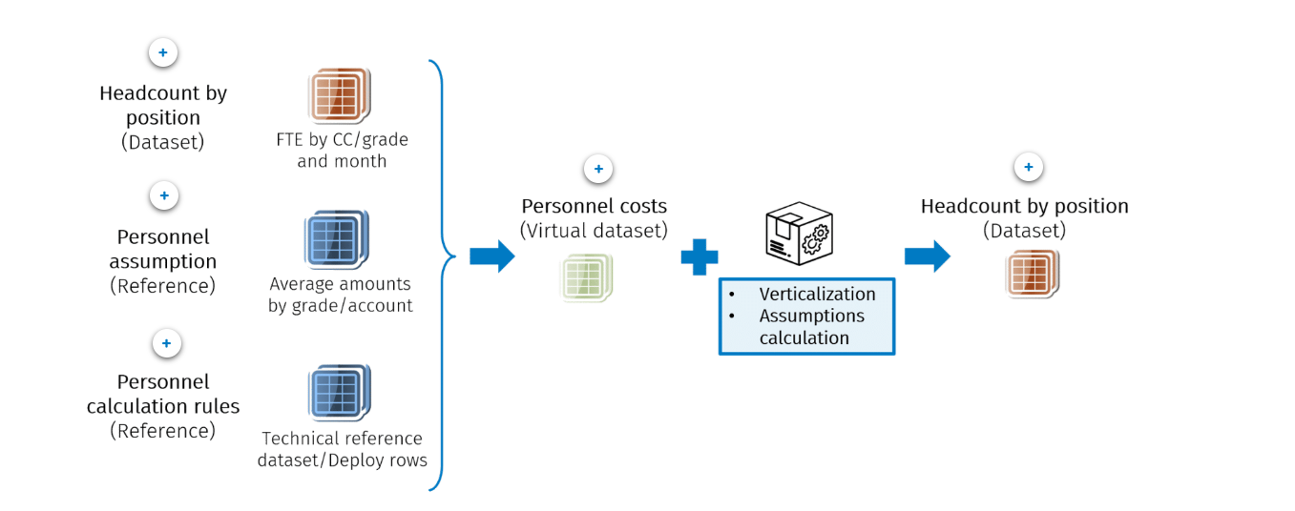

- Headcount by position : This dataset is utilized to store both input data and the results of the calculation. Initially, it provided amounts of headcount by position distributed in 12 nunber fields : one for each month
- Personnel assumption: This dataset holds the average amounts by grade and account of the assumptions
- Personnel calculations rules : This a technical dataset intended for use in data preparation to deploy rows
- Personnel costs : This is the virtual dataset you will be required to create. It is aimed at preparing data and generating the formula that drives the calculation rule.
- Headcount by position : At the end if the calculation, the result fo all personnel cost accounts will ne verticalized and stored in a number field. Amounts are identified by Scenario, Period entity and grade

Implementation details : datasets structure
The Assumptions business case environment involves the following datasets. Check the boxes below to gain insights about their fields' structures and meaning.

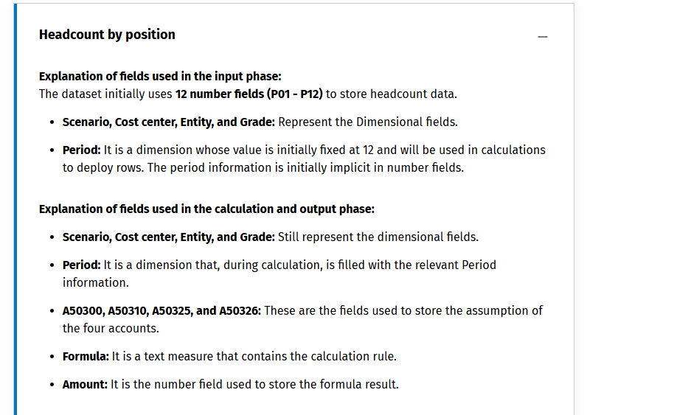

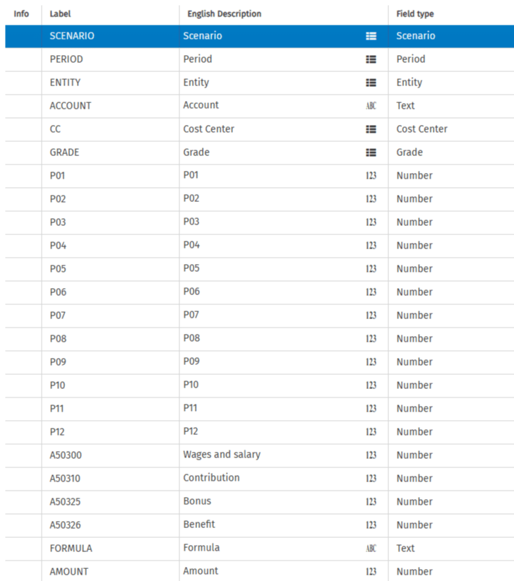

Personnel Assumption
Personnel Assumption is a reference dataset deployment used to store Assumptions in four number fields: Wages, Contributions, Bonus, and Benefits.
- Scenario, Period, Entity, and Grade: Represent the dimensional fields.
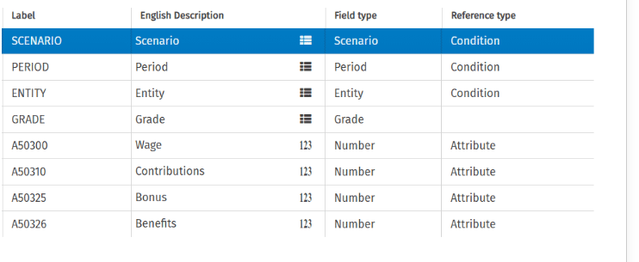

Calculation rules
Calculation rules is the technical dataset, utilized to unpivot data and for generating the calculation rules.
- PER: A text field with values P01 to P12, representing labels for the 12 number fields in the Headcount by Grade dataset.
- ACC: A text field with possible values: A50300, A50310, A50325, and A50326.
These labels correspond to fields in the Personnel Assumptions dataset. The dataset is prefilled, and each ACC value (A50300, A50310, A50325, A50326) is combined with each PER value (P01 to P12).
- Period In: A field with a fixed value of 12, used for unpivoting the result. The dataset stores a total of 48 rows, calculated by combining 4 ACC values with 12 PER values (4 x 12 = 48 rows).
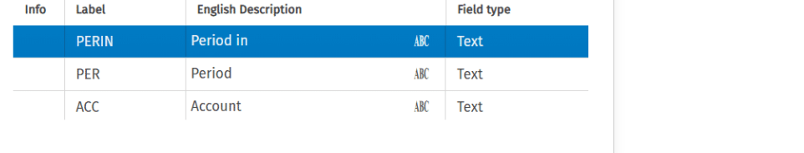

Enrichment with formula field

The first step in the business case involves creating a virtual dataset to prepare data and define calculation rules based on assumptions.
Personnel cost virtual dataset is generated by joining Headcount by position, Personnel assumptions, and Personnel calculation rules.
This provides a detailed guide on creating the Personnel cost virtual dataset and viewing the retrieved data.
Below you can find the step-by-step explanation of the Virtual dataset creation.
Headcount by position is joined to Personnel assumptions by Scenario, Period, Entity, and Grade.
The period value is arbitrarily set to 12 in both datasets. It will be used in the unpivoting of the data.
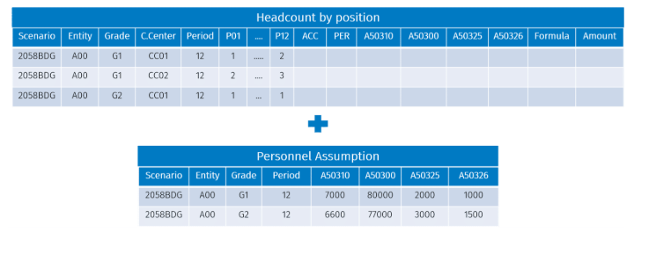

Thee first goal of the join operation is to enrich Assumption fields.
In the image below, you can see the result in the field chosen during the virtual dataset definition.
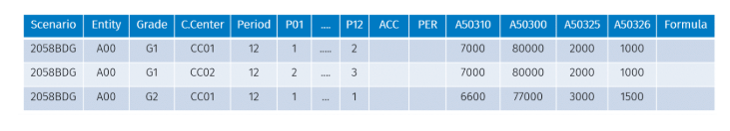
Joining Headcount by position and Personnel Assumption with Personnel calculation rules is required to unpivot data.
The unpivoting process is driven by the join operation between the PERIOD field of Personnel Assumptions and the PERIN field of Personnel Calculation Rules.
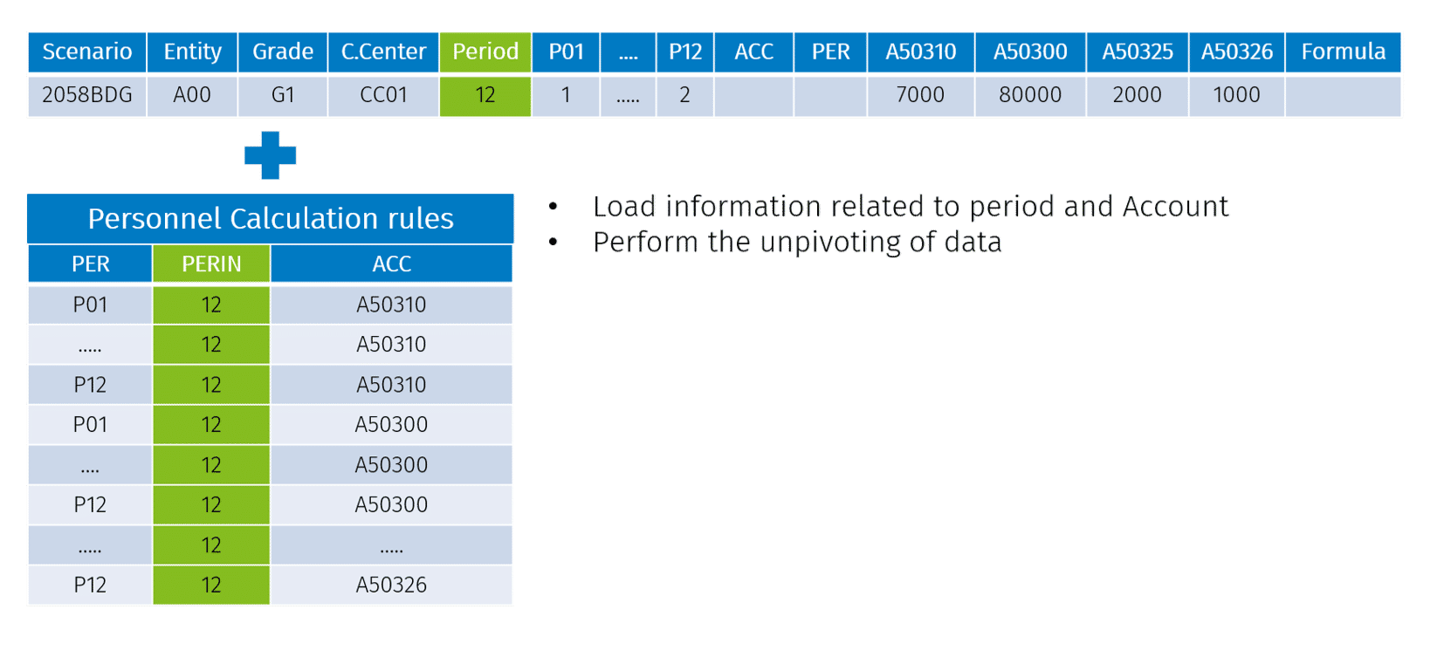
The operation generates a deployment of 48 rows for each existing row in Headcount by position. Additionally, the operation enriches fields ACC and PER. These fields will be used to compose the Formula that will drive the Calculation rule.

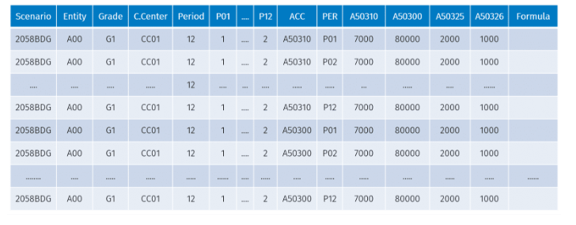
The fields of a virtual dataset can be derived from the joined dataset or manually added as formula fields. The calculation rule is stored in a dedicated formula field within the virtual dataset.
The formulas required to estimate Wages, Contribution, Bonus, and Benefit are as follows:
- In the fields A50310, A50300, A50325, and A50326, the average monthly amounts are defined as Assumptions.
- To determine the total amount for each period, you must multiply the Assumptions value by the related Headcount stored in the fields P01, P02, P03...P12.
Therefore, the formula results from concatenating the values of field ACC and field PER, as demonstrated in the image below.
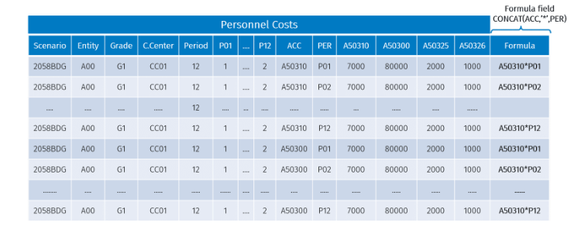

Enrichment with formula field

In the DTP that calculates Cost Planning you will use an operation called Enrichment with formula field.
This formula enriches a dataset's Target field by applying a SQL formula from another dataset's Formula field. In this business case, the operation stores the result in the AMOUNT field by calculating the formula in the FORMULA field.

Cost planning calculations via DTP

Once the data has been prepared using the virtual dataset, the business case requires the configuration and execution of a DTP setup to calculate the results. It is necessary to display these results in a multidimensional matrix utilizing the financial reporting tool.
The DTP comprises two activities, both targeting the Headcount by position dataset.
First activity
The first activity includes two operations:
- Operation 1
Insert from other dataset
This operation is used to load the view generated from the virtual dataset previously configured onto the target. In addition, it will retrieve Account and Period values from fields ACC and PER using string manipulation formulas.
Operation 2
Enrichment with formula field
This operation calculates the result of the formula stored in the field FORMULA and saves it in the target field AMOUNT.
The image below shows the formula written in the Formula field and the result calculated in the Target field Amount.
Please refer to the image below to observe the updated values of Account and Period following the modification of their original fields ACC and PER as shown in the Operation 2 image.
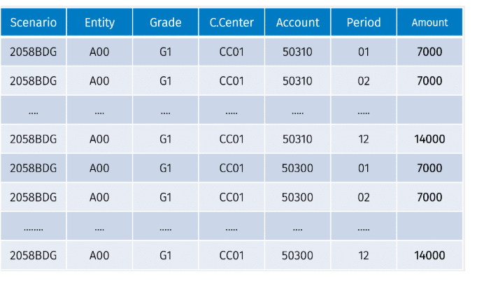

Second activity
The objective of the second activity is to enhance data storage efficiency. The Insert from other dataset operation eliminates rows with amount zero and applies aggregate functions to reduce the number of rows to be processed.
A specific form can be executed to present the results on a multidimensional matrix derived from the Headcount by position dataset.
DTP Cost of personnel calculation: creation and running
Watch the demos below to gain a better understanding of the concepts just explained. You can see the creation and running of DTP Cost of personnel calculation.

Knowledge check

Budgeting planning and forecasting 1 – Asset depreciation

Learning objectives
Learning objectives :
- The definition o asset depreciation
- The attributes and accounts involved in the asset depreciation process

Asset depreciation and asset class
An important part of the budget process is planning new investments. The purchase of new capital assets and their depreciation is usually referred to as Capital Expenditure or simply CAPEX.
Asset depreciation is the systematic spreading of an asset cost over its expected useful life.
Assets can be grouped into classes. An Asset class includes financial assets with similar characteristics and market responses. You can define an asset class by specifying these features:
- Expected useful like: This term indicates how long an asset is anticipated to remain in service and produce economic benefits. It can be expressed in a number of months.
- Depreciation %: The rate at which the value of an asset decreases each month during its useful life
- Accounting model: The list of input and output Accounts involved in the asset depreciation calculation.

Asset depreciation : accounting model
Asset depreciation implementation requires the definition of an accounting model. The module receives one input account and will fill three output accounts.

Input account:
- Asset purchase This is the account designated for booking new asset purchases.
  - Data entry must be performed on this account for each new asset acquisition. The entered amount will then be utilized to calculate the output values.
  - It can be a dataset field of type Number or an Other Stocks account.
Output account
- Asset : This represents the investment value. In the month of purchase, it is booked with an amount equal to the value of the asset purchase. It is a balance sheet account type variation
- Depreciation cost: This account stores the depreciation installment. It is booked with an amount equal to the investment value multiplied by the depreciation percentage for that month. It is a profit and Loss account type Normal
- Depreciation fund: This account completes the double-entry calculation and is stored with the same value as the depreciation cost but with the opposite sign.
  - On reporte du PL les informations au BS
  - It is a balance sheet account type Variation

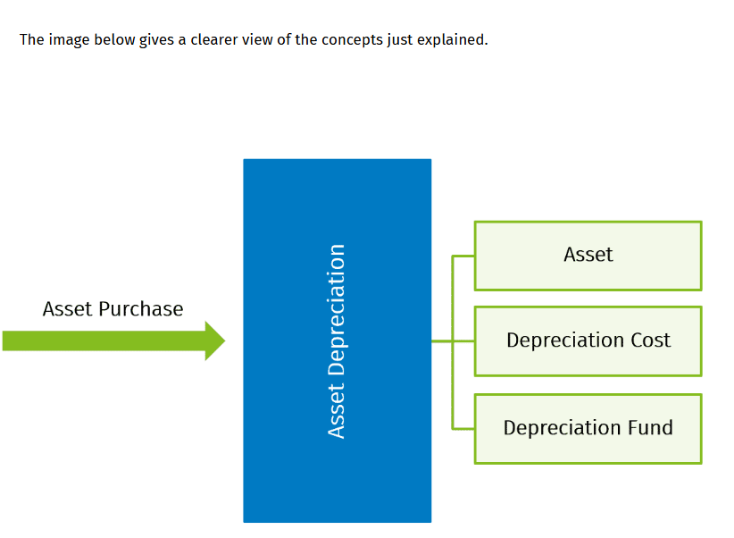

Example :
Example
This example aims to explain the roles of the accounts involved in an asset depreciation calculation, showing the values they assume during their expected useful life.
- Suppose that you insert 1000 as the value of a new asset purchase, and its expected useful life is five months.
- The asset's depreciation calculation will provide the results shown in the table below.
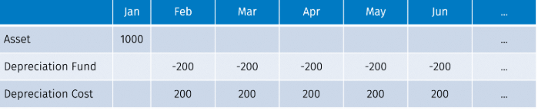
- The asset amount is booked at purchase value only in the month of acquisition, while depreciation is calculated monthly by multiplying the investment value by the depreciation rate of 20%.
As you can see in the table, Depreciation Fund has the opposite value of Depreciation Cost to complete the double entry.
- The Depreciation Cost and Depreciation Fund are booked starting from the period after the asset purchase.

Tools to implement asset depreciation in CCH Tagetik

In CCH Tagetik, asset depreciation is calculated by filling the accounting model accounts. This can be implemented in both workspaces using various tools.
The Financial Workspace offers a built-in data processing to calculate the depreciation plan of new investments. It is necessary to define:
- Assets class
- The depreciation method (Number of months of useful life and depreciation percentages for each period_
- The accounting model
It is necessary to define the asset class on custom dim 3
The implementation on the Analytic Information Hub requires data modeling skills to create the datasets to store necessary data properly. You can take advantage of virtual datasets and datasources to manipulate data and eventually the configuration of a DTP to fill the accounting model accounts.

Knowledge check

Business Case asset depreciation Workflow

Learning objectives
In this module, you will learn:
- How to manage asset purchase and depreciation in Analytical Workspace Dataset
- How to configure DTP operations to calculate asset depreciation

Requirements
This business case aims to teach you how to implement Asset depreciation in the Analytical Workspace.
Consider that your asset purchases are collected in a dedicated dataset, and asset depreciation workflow is composed of these three steps:
- Define amortization logics
- Book the accounts involved in the depreciation calculations
- Assess results in a report
Before the implementation, you need to fix certain assumptions:
- Use a flat depreciation method. It means that depreciation rate has an even distribution on each month depreciation
- Depreciation starts one month following the asset purchase
- Since carry forward is not implemented to following scenarios, results will be provided only on periods related to running scenario
- The maximum useful life is 120 months, equivalent to 10 years
- Data related to purchases from previous scenarios is not considered. Only assets purchased from the current scenario are taken into account
- The accounts involved in the calculations are asset investment value, depreciation cost and depreciation fund.

Workflow components
The asset depreciation workflow involves the following steps:
- Defining a datasource using advanced SQL function to set the asset definition
- Data preparation : Creating a virtual dataset to prepare the data necessaire for depreciation calculations
- Asset depreciation calculation : Performing DTP operations for calculating and storing asset depreciation, including :
  - Use fo source filters
  - Application of string manipulation formulas in matching fields

Asset depreciation definition
The first step of the workflow consists in the Asset Depreciation Definition through a datasource.
The image below shows that the datasource definition involves the Asset definition and Period deployment datasets. The rows generated from the view will be stored in the Depreciation definition result dataset through a DTP.
Click on the buttons over the image to discover more about the datasets involved in the workflow and their meanings.

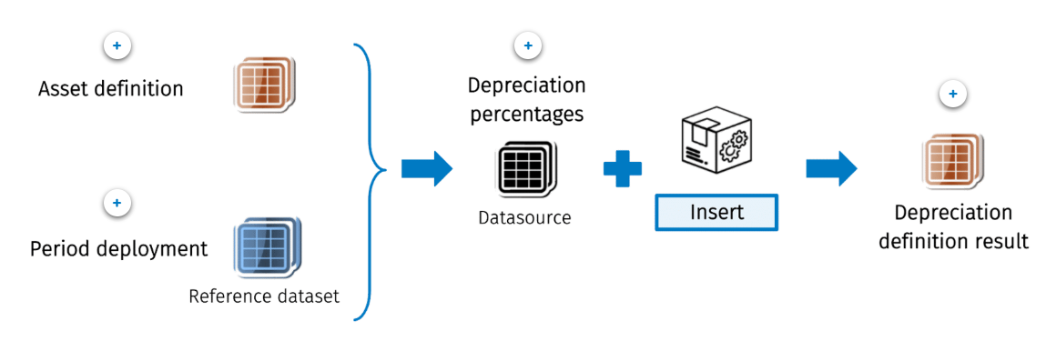
- Asset definition : This dataset stored asset definitions. It provides information about periods of useful life and the codes of the target accounts involved in depreciation for each asset class
- Period deployment This is a technical dataset used in data preparation to deploy rows.
- Depreciation Percentages : This is the datasource that stores asset depreciation definition
- Depreciation definition results This is the target dataset on which you will load the data of the view generated from the datasource.
Implementation details
Asset definition dataset
In the image below, you can see the Asset definition dataset structure.
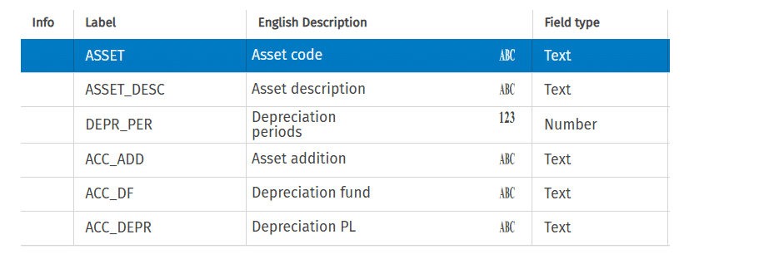

Label field | Meaning
Asset class code and description | These represent the asset code and description.
Depreciation periods | This is the number of periods of the asset's useful life.
Asset addition, Depreciation fund, and Depreciation PL | They are the Account codes of Asset depreciation accounting model.

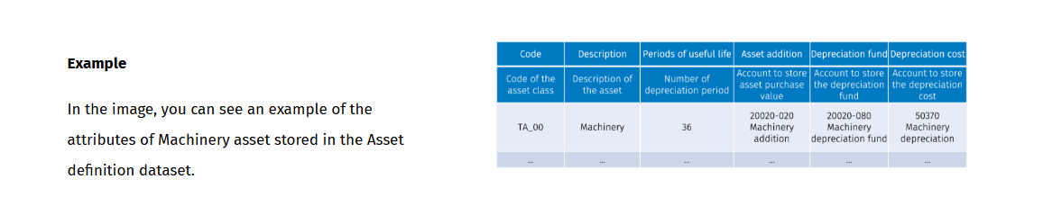
Period deployment dataset
The Period deployment is a reference dataset with a single number measure that stores numbers from 1 to 120. It will be used in a join operation in the datasource query definition to deploy a number of rows equal to the maximum useful life of the asset.
Depreciation definition result dataset
In the image below, you can see the Depreciation definition result dataset structure.
This is the target dataset, and the necessary fields are Asset class, the number of Depreciation periods, the Depreciation percentage, and the related Period of depreciation.
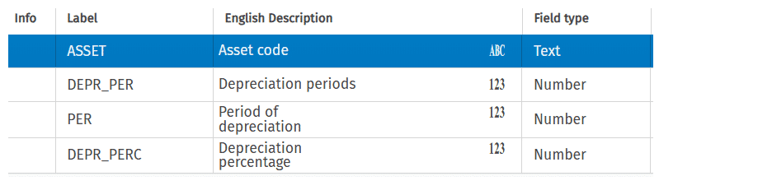

Asset depreciation Definition Workflow

This workflow step aims to convert the asset definition table to a format showing the flat depreciation percentage for each period, as shown in the image below.
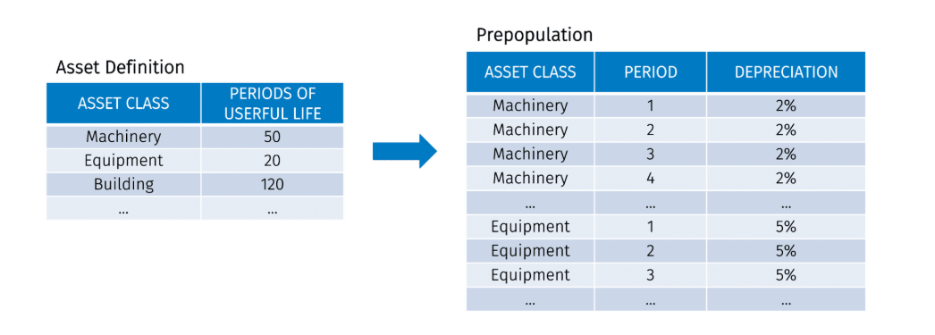

To obtain a dataset that matches the format displayed in the image, create a datasource with the following features:

- Use a cross-join function between the Asset definition and Period deployment datasets to generate rows for each asset class, corresponding to the number of periods of useful life.
- Apply a filter where Period <= Period of useful life to ensure the correct number of rows for each asset class.
- Calculate flat depreciation as 1/Period of useful life.

The image below displays the view generated from the datasource. The datasource must filter only periods highlighted in the red square.
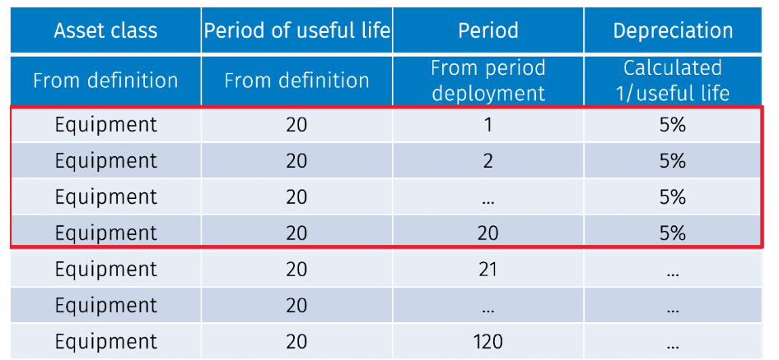
The maximum number use full rows of the assets are stored in a dataset.
The depreciation % is made in a query. For each asset class : Join asset depreciation with the period deployment.
Apply filter to delete the period exceeding the depreciation period.
DTP CAPEX definition
Once you have defined the Datasource, you must set up a DTP to load the result in the physical dataset called Depreciation definition result. The DTP includes one activity, which performs the Insert from other dataset operation.
The source is the datasource 52 Depreciation % that has already been defined. Matching fields are not required if field labels of source and target dataset correspond.
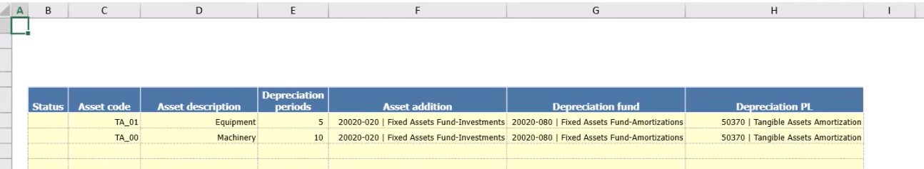
Have t

Data preparation
This phase of the workflow involves preparing asset depreciation for calculation. You will utilize a virtual dataset. The section highlighted in red in the image below outlines that the virtual dataset definition involves Asset Definition, Asset Purchase, and Depreciation Definition Result datasets.
Depreciation definition result is the dataset completed in the previous step
Once the virtual dataset is generated, the next step involves calculating and filtering the results using a DTP. The DTP target is the Asset report dataset, which has a structure suitable to display the accounting model for reporting purposes.
Click on the buttons over the image to discover more about the datasets involved in the workflow and their meanings.

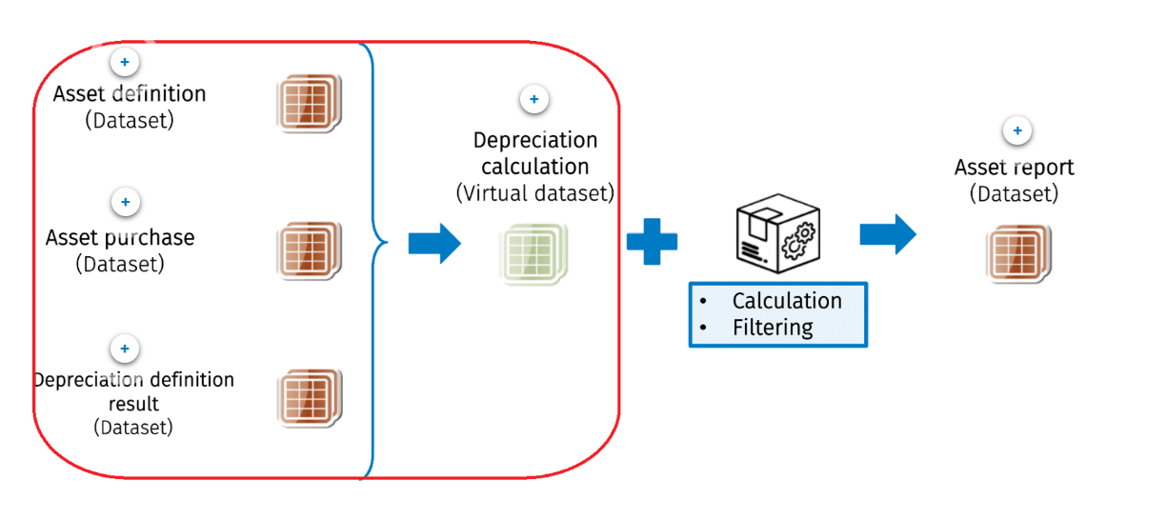

- Asset definition The dataset that stores Asset definition.
- Asset purchase The dataset that holds the definition related to each budgeted purchase that must be depreciated
- Depreciation definition result : The dataset generated in the first step of the workshop.
  - It holds the depreciation plan data such as Asset class, the number of depreciation periods, the Depreciation percentage, and related Period of depreciation.
- Depreciation calculation (Virtual dataset) : This dataset is designed to prepare data for calculating depreciation. You will need to create this Virtual Dataset.
- Asset report: The dataset that stores the depreciation calculation result.
This dataset has a structure suitable to be displayed for reporting purposes.

Implementation details
In this step you must prepare data for Asset calculation. The implementation involves creating a virtual dataset that generates a view joining the following datasets:
- •
Asset definition
- •
Asset purchase
- •
Depreciation definition result
Asset definition dataset
For each Asset class, it provides information about Periods of useful life and the codes of the target accounts involved in the depreciation. It has also been used for Depreciation definition result in the previous step.
In the image below, you can see the Asset definition dataset structure.
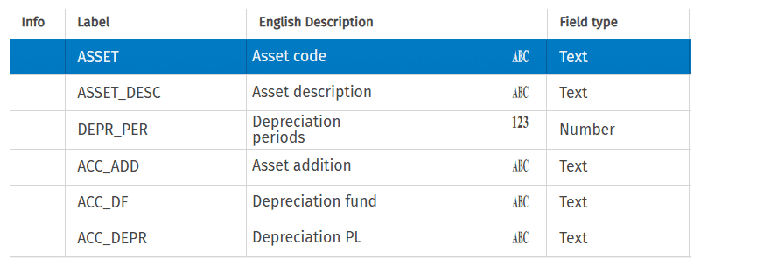

Asset purchase dataset
This dataset holds the definition related to each budgeted purchase that must be depreciated.
Its fields include Entity, Asset class, Purchase date, and Purchase price.
NOTE: Purchase date information is split into two number fields, indicating the year and month of purchase.
In the image below, you can see the Asset purchase dataset structure.
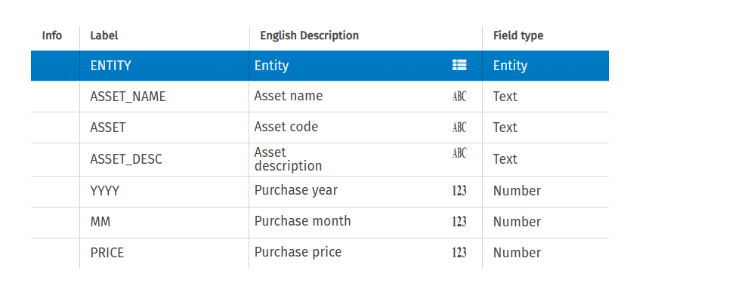

Depreciation definition result dataset
This dataset drives depreciation calculation. It includes the following fields: Asset class, the number of Depreciation periods, the Depreciation percentage, and the related Period of depreciation.
In the image below, you can see the Depreciation definition result dataset structure.
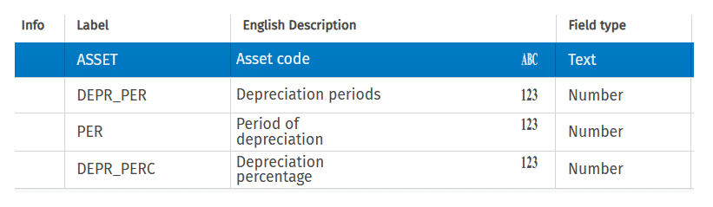

Data preparation Workflow
The three datasets, Asset definition, Asset purchase, and Depreciation definition result, are joined by the ASSET field.

The image below displays the fields of the virtual dataset and their dataset sources.
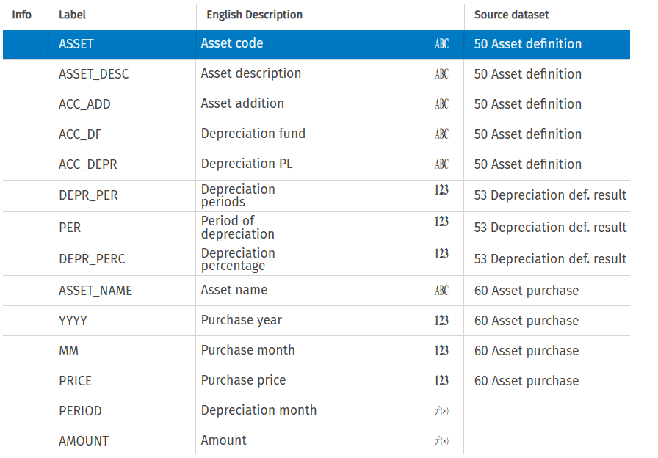
Refer to the table below for the different labels of the dataset fields and their meanings.
Label fields | Meaning
Asset | The Asset class code
Asset addition, Depreciation fund, and Depreciation PL | They represent the code of the accounts involved in the depreciation accounting model
Depreciation periods | The number of periods of useful life
Period of depreciation | The specific period for which the depreciation is calculated
Depreciation percentage | The flat percentage used in the calculation
Purchase year and month | The data of asset purchase
Price | The Purchase price
Depreciation month | Formula field that represents the calendar period of depreciation. It is calculated as:  MM + PER -> Purchase month + Period of depreciation
Amount | Formula field that represents the depreciation amount of each period. It is calculated as:  PRICE x DEPR_PERC -> Asset Price x Depreciation percentage

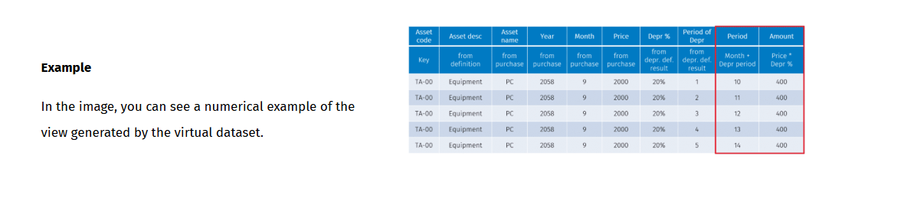

The goal of the virtual dataset is to prepare data for the calculation step. The definition generates a deployment of rows among the three datasets. The displayed data needs to be filtered and manipulated through a DTP in the last step.

Asset Depreciation Calculation
This step of the workflow involves calculating asset depreciation through a DTP.
Data from the Depreciation calculation virtual dataset will be processed and stored in the Asset report dataset, which has a structure suitable for displaying the accounting model for reporting purposes.

The section highlighted in red in the image below is implemented in this step.
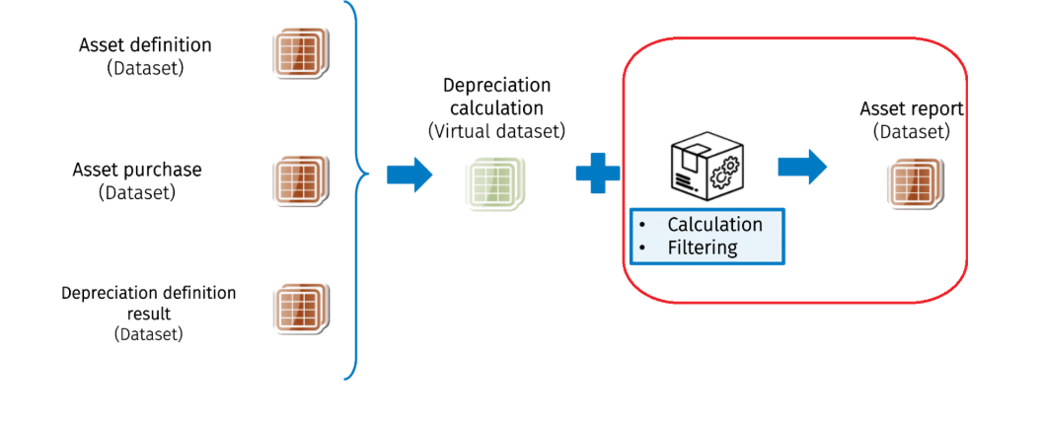

Implementation details
The DTP target dataset is the Asset Report. Below you can see its structure.
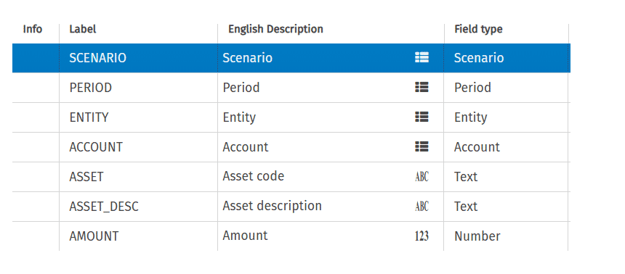
Label field | Meaning
Scenario, Period, and Entity | These are the environment dimensions.
Account | This is the account code, and its range is among the accounting model accounts.
Asset | This is the depreciated asset.
Amount | This is the number field used to store the value of the account.

This structure is appropriate for presenting the account involved in depreciation over time dimension within a report

Asset depreciation calculation workflow
Operation 1
The initial operation loads the asset investment value. Load the Amount price.
- The source filter is set to month equal to the purchase month of the input price.
- The scenario is retrieved from context,
- The period value requires calculation using string manipulation functions.
- The amount is retrieved from the price field.
Operation 2
This operation loads the Depreciation fund.
- Source values are filtered based on periods within the planning year.
- The scenario is retrieved from the context.
- The period value is calculated using string manipulation functions. Right(Concat(‘0’floor(PERIOD)),2)
- The amount is retrieved from the amount source field with the sign changed.
Operation 3
This operation loads the Depreciation cost, namely Depreciation installment value.
- Source values are filtered only for periods within the planning year. Period<12
- The Scenario is retrieved from context.
- The Period value needs to be calculated using string manipulation functions. Right(Concat(‘0’floor(PERIOD)),2)
- The Amount is retrieved from the Amount source field.
After running the DTP, you can display the results in a report using a multidimensional matrix derived from the Asset result dataset. This is shown in the image below.
The matrix shows the value of the accounting model along the periods of the running scenario. You can notice that the Investment value is stored only in the purchase assets period. Depreciation Fund and depreciation cost have the same value but with opposite signs. Amortization starts one month after asset purchase.
In summary, implementing asset depreciation on AIH necessitates an appropriate dataset design, advanced usage of datasource and virtual dataset for data preparation, alongside DTP configuration to fill the accounting model accounts.

Knowledge check

Budgeting, planning and forecasting 1 – Reporting versioning

Reporting and versioning
In this module, you will learn:

The features of a dataset structure suitable for reporting purposes

How to configure a Data Transformation Package (DTP) to load data from calculation datasets into a dataset suitable for reporting

Reporting
In planning projects, the design of a dataset's structure is influenced by calculation complexity and data entry requirements.
At the end of the process, calculation results need to be displayed in a financial reporting tool. Often, the original dataset design is not suitable for this purpose. Therefore, additional datasets with a structure suitable for reporting purposes need to be created, and results must be loaded into these datasets. A dataset structure suitable for reporting should include:
- All relevant dimensions
- Necessary number fields
It must allow the use of all the standard built in functionalities such as conversion and time rollup
Data loading from original structure to reporting structure is performed using a DTP.
The DTP process can be automatically triggered at the end of the data entry and calculation process to keep both datasets aligned. The image below shows a dataset with a structure designed to ease the DTP calculation. Each number field represents the amount in a different period. The presence of Scenario and Period dimensions allows you to create multidimensional matrices, but this structure is not suitable for reporting purposes analysis.
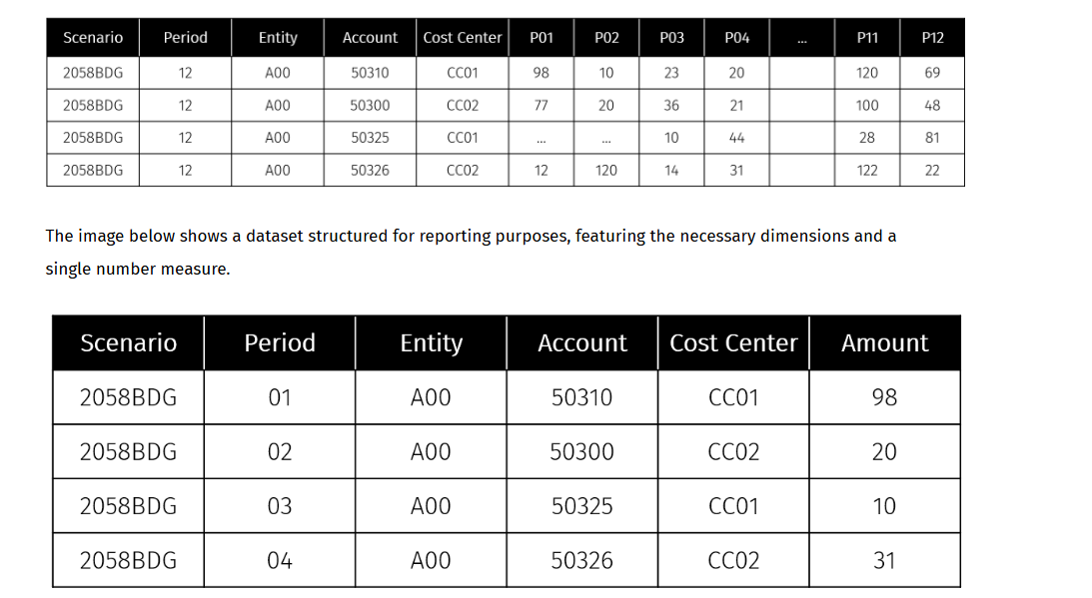

Reporting DTP : Execution condition and deletion policy
Imagine you manage an Analytical Workspace with many complex datasets: each of these datasets has its own data entry structure, not suitable for reporting purposes, that needs to be normalized.
In the image below you can see an example of the general structure of a DTP used to load data from the different data entry datasets in a unique dataset that has a structure suitable for reporting purposes.
Each dataset for data entry is related to a dedicated activity that manipulates and stores data in a dedicated Typology of dataset Reporting.
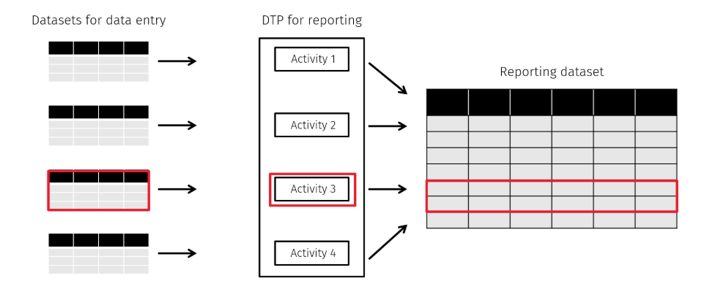
DTP implementation

An optimized DTP implementation should consider these aspects:
Execution condition
Each activity should run independently, as datasets may load at different times. Set a Run condition on each activity, driven by a runtime parameter, to load the desired dataset and prevent unnecessary data movement.
Deletion Policy
The Update of Reporting Layer can result in data loss. To prevent this issue
reporting layer filter condition on the account codes managed in the different activities.

To configure a DTP to load data from various dataset to a reporting dataset. The reporting dataset includes all the relevant dimension and relevant number field for amount.
3 activities, each related into different dataset data entry to be loaded into the reporting dataset.
Each of them have a reporting condition and reporting layer filter to delete the account that are related to the DE form dataset.
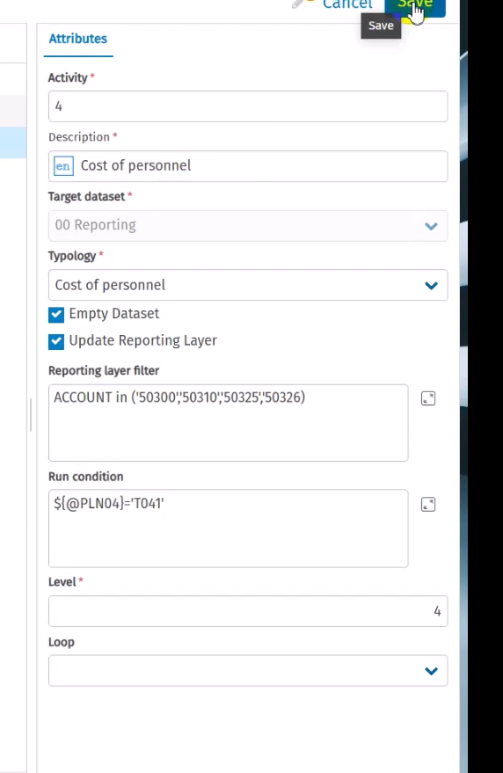
How to link DTP Reporting to a data entry form and how to run it at save event by selecting the reporting dtp and select the reporting parameter, to be able to run only the activity needed and related to the DE form.

Versioning : Snapshots scenarios
In this module, you will learn:
- How to perform data versioning using Snapshot scenarios
- How to configure and run Snapshot scenarios
Snapshot scenario definition
When you put in writing the budget, it is useful to keep several versions of planning data related to the same original scenario. The different planning versions can be analyzed, compared and evaluated before choosing the final version.
CCH Tagetik provides a tool for copying and freezing multiple versions of your planning in specific scenarios called Snapshots. After selecting the desired version, it can be restored to the original scenario. This feature is available in both Analytical and Financial workspaces.
The image below shows an example where the 2058 Budget scenario has three different versions of data.

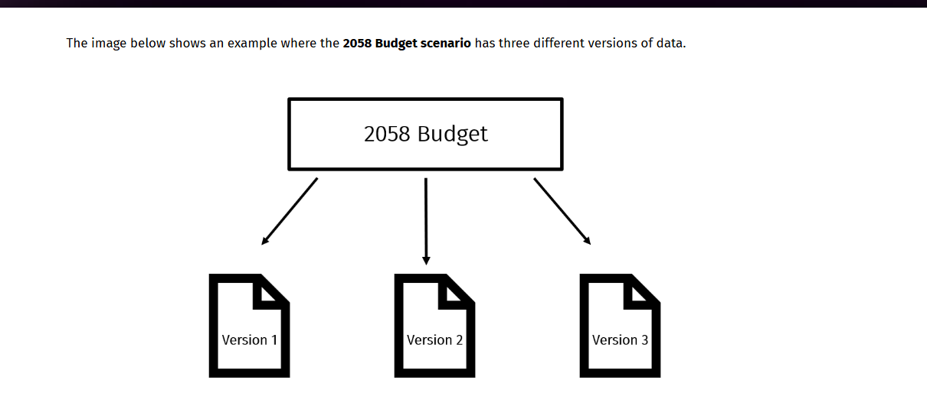



Example of snapshot usage:
- Driver based planning using alternative drivers
- Top down approach insert different adjustments
- Budgeting with different hypotheses changing the amount of the assumptions.

You can capture the results of the alternative methods and numbers in various snapshot scenarios. After analyzing and comparing the outcomes, you may restore the selected snapshot to the original scenario.

Snapshot Scenario configuration
Snapshot scenario requires an official original scenario associated with the planning application process.

More specifically, the official budget scenario presents the following characteristics:
- It is the live scenario, used for data entry and data processing
- It is the source to copy data in the different snapshot scenario
- It is the target to load back data from the preferred snapshot version

On the original Scenario element, specify its snapshots and assign a version number to each one.
Snapshots scenario must have the same periods as the original scenario, but they do not need to be linked to a process.

First, you have to enable snapshot scenario data processing in the process configuration, then it is necessary to specify the dimensions that will be managed using the following settings:
Run by :
This option allows you to select the running time dimension of the snapshot.
The options are:
- Process: This option includes all the scenarios and periods associated to the process.
- Scenario: This option includes all the periods of the specified scenario.
- Scenario/Period: This option includes one period of one scenario.
Dimensions on which to filter
The snapshot is run on a partialized set of data of the chosen dimension. You can select the following dimensions:
- Entity
- Category
- Custom dimensions
The creation and restoration of snapshot scenarios can be run through the process cockpit from the Actions menu.
The table below indicates which datasets are impacted by the snapshot, depending on where the snapshot is executed

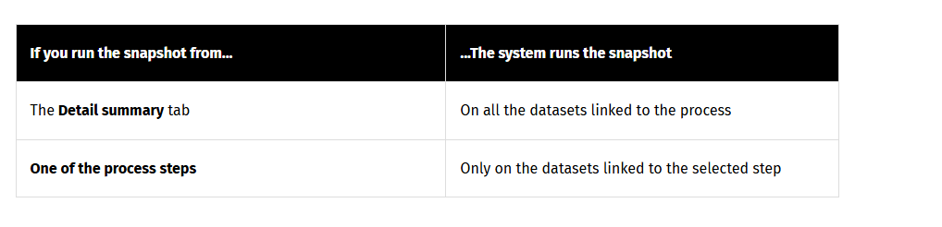

Creation phase
During the creation phase, when copying data from the official scenario to a snapshot scenario, you must specify the following:
- The Version number of the target snapshot scenario
- A description of the copy operation you want to run
- A comment
Restoration phase
During the restoration phase, which involves copying data from a snapshot scenario to the “official” scenario, you must specify the Version number of the source snapshot scenario.

Reporting and versioning : Takeaways.
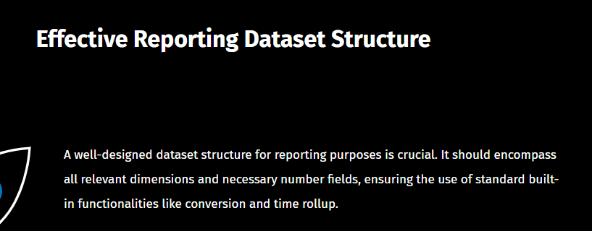
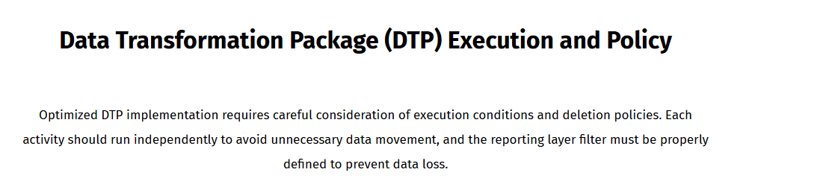
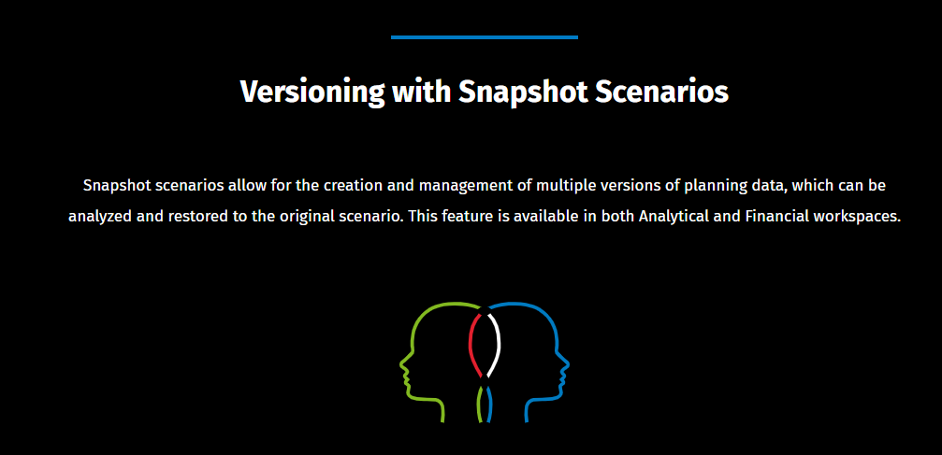
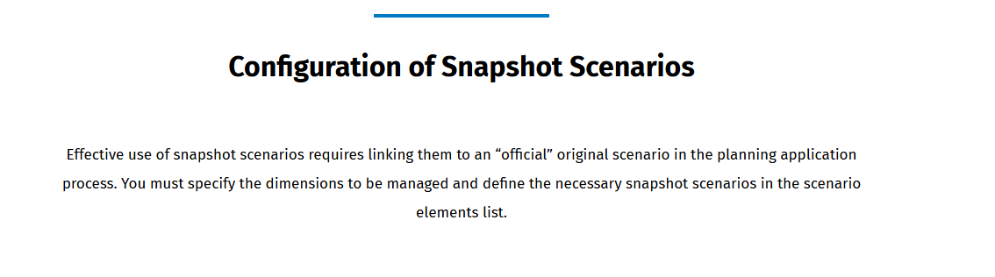
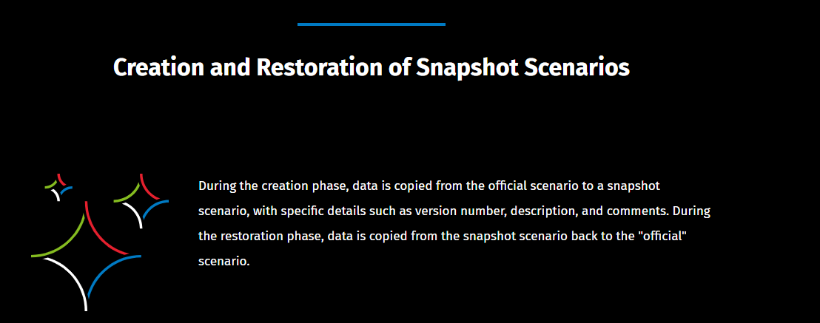

Forecast methods

Familiarize yourself with forecasting
In this module, you will learn:
- The definition of forecasting and its benefits in company management
- Judgment and Quantitative forecasting methods
- Forecast methodologies and models used in CCH Tagetik

Leaning objectives

Definition of forecasting
Forecasting is the process of making predictions about future events or conditions based on analysis of past and present data.
It is commonly used in fields such as economics, finance, and business to support planning and decision-making. It provides an estimate of outcomes based on a strategic plan and offers insight into the future trajectory of a business, considering past and current events as well as management perspectives. It is a prediction of anticipated developments given the existing circumstances.

Benefit of effective forecasting
Forecasts help to update the budget in a timely fashion and are used by companies to decide how to allocate or reallocate their budget, so that they make a better-informed decision. Forecasts are flexible and change regularly when there are operational, market, inventory, or business plan changes. This flexibility is essential to enable executives to act and update data in real time in today's competitive and changing business environment.
he budget is essentially a roadmap showing where a company aims to go, as a projection. Cash flow, goals, targets and the company’s current financial position are used to determine budgets. While goals are an important part of budget setting and progress, they aren’t always met due to fluctuations in the market and unforeseeable events or reallocation
The importance of forecasting is related to the dynamic markets in which customers typically operate. Without forecasting, the budget remains static and may have low validity because it could become outdated by the time it is completed and may not always be suitable for its intended purpose.

Forecasting in CCH Tagetik
Forecasting in CCH Tagetik can be implemented across all functions of an organization, helping to meet different needs.
You can use the data to create a forecast for a required purpose, connecting planning, budget and actual data through the Analytical Information Hub (AIH) and the Financial Workspace (FW). AIH allows you to manage different data models suitable for each function involved in the forecasting process, while the FW provides built-in forecasting models for financial forecasting. In addition, CCH Tagetik includes Predictive Intelligence to provide estimates based on Machine Learning.

Judgement and quantitative forecasting
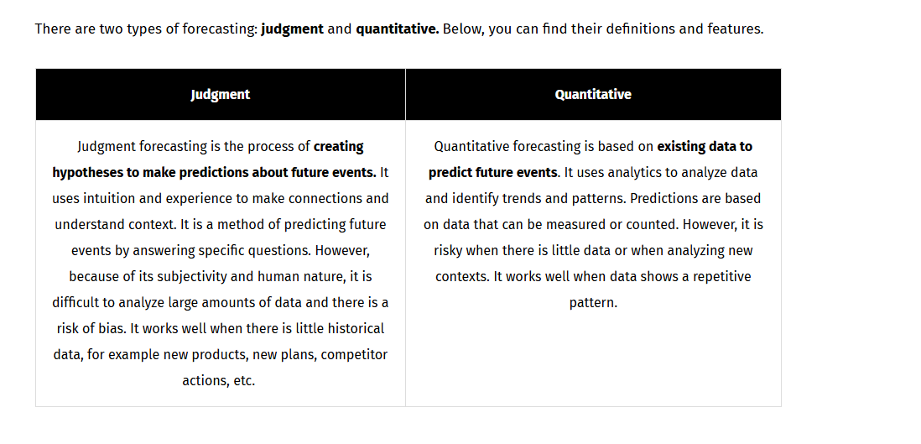

Statistical Forecast
Statistical forecasting is quantitative forecasting based on analyzing a set of data in a time series. It helps to plan more efficiently and accurately.
There are two general approaches to statistical forecasting :
- Time series forecasting
- Model bases forecasting
Both occur when you make scientific predictions based on historical time data but they differ in their purpose, requirements, results, application, and implementation.¸

Time series Forecasting :
- Purpose : The purpose of time series forecasting is tactical (short-term actions to achieve goals), and it identifies seasonal patterns.
- Requirement and results : Time series forecasting needs historical data and results in short-term adjustments.
- Uses and implementation : It is generally used in demand planning, production planning, and inventory management. It can be implemented through predictive intelligence.
Model based forecasting
- Purpose The purpose of the Model based forecasting is strategic (long-term goals) and it takes into account changes in the business environment.
- Requirements and results Model based forecasting needs management insight and leads to changes in business practices.
- Uses and implementation : It is used in marketing, resource allocation, business optimization, and business plan comparisons. It can be implemented in the Analytical Information Hub in a completely custom way or in the Financial Workspace through a built-in solution to define forecast models.

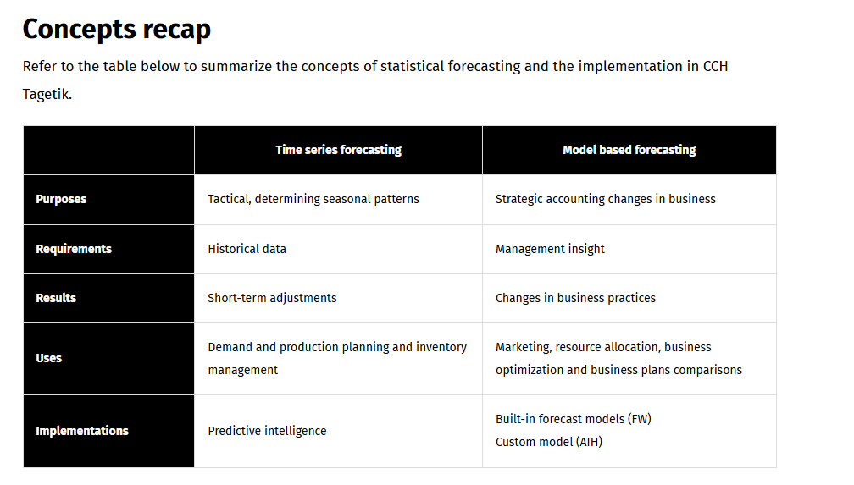

Forecast methodologies

Two different forecast methodologies :
- Static : The time horizon is set on a fixed period, for example, the end of the year, regardless of when the forecast is calculated
  - The first one is annual, static, and by definition, it ends at the end of the year. If you consider that the current period is March 2030, the annual forecast planning will be until December 2030.
- Rolling: The time horizon is set for a predefined number of months, for example, 12 or 18. In this way the forecast is produced for 12 or 18 months in the future, starting from the current period.
  - The second, on the other hand, is rolling and depends on the number of periods to be forecast in the future (let's consider 12 months). So, if the current period is March 2030, the rolling forecast planning will be until March 2031.
The process of forecasting/reforecasting can be updated either quarterly or monthly

Forecast Models
To develop a forecast model, you need to define the following aspects:
Actual data
Data available from the beginning of the year till the current period. For example, if March has been closed, this means the data from January to March.
Forecast source scenario
Data used to populate the remaining forecast periods, typically budget data or previous forecasts.
First forecast period
It is the first period populated with the data generated for the forecast (considering the actual data example, it means from April onwards), while previous months remain populated with actual data.
Logic of population of the forecast periods
There are two main logics explaining the two model types:
- Hold to-year: monthly actual data and data coming from forecast source scenario (e.g. budget) are copied as they are in the forecast scenario. With this logic, forecast data follows the business trends.
- Hold the annual total: monthly actual data is copied as it is, whereas data for forecast periods is re-proportioned to keep the same annual total amount of the forecast source scenario. With this logic, forecast data are adapted to achieve the annual financial targets.

Hold to year and hold the annual total models
Hold to-year and Hold the annual total models
How do you represent them?
Hold to Year
To represent it in the system, you need to copy the existing Actuals (months) to the Forecast scenario and fill in the missing periods with budget data (or previous Forecast scenario).
As you can see in the image below, in the first half of the year (up to June), the cumulative actual data differs from the budget/previous forecast. There is a difference of 600, which is a loss and will not be recovered until the end of the year. This is due to the Hold to-year logic, which follows the business trends and reports the data as it is, month after month, despite the losses. The values at the end of the year will certainly be different (observe the values 11.700 vs 11.100).

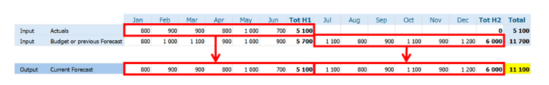
Hold the annual total
On the contrary, Hold the annual total is represented by copying the existing Actuals (months) to the Forecast scenario, setting the forecast annual total, equal to the budget or previous annual total, and filling in the missing periods by distributing the difference between the actuals and the annual total.
As you can see in the image below, in the first half of the year (up to June), there is again a difference of 600 between the actual data and the budget or previous forecast. In this case, however, the "loss" is made up by redistributing the difference over the remaining months, so that the annual totals are the same.
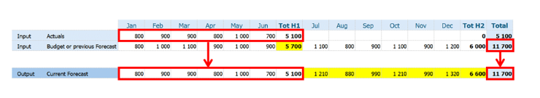
How is this done?
It is calculated with a formula that recalculates the values on the forecast by re-proportioning the values with a partition (distribution) coefficient. The formula to get the re-proportioned value is:
FP = SFP x (1+(SF-A)/RSF)
Refer to the table below to better understand all parts of the formula.
Acronyms | Meaning
FP (Forecast period) | Value of the period in the forecast scenario
SFP (Source Forecast Period) | Original value of the period present in the source forecast scenario ➔ 1100, 800, ...
SF (Source Forecast) | Total of the values of the previously forecasted months for which the actuals are available ➔ 5700
A (Actual) | Total value of Actuals months ➔ 5100
RSF (Remaining Source Forecast) | Total of the values of the remaining months in the forecast source scenario (budget) ➔ 6000

The result of the coefficient (SF-A)/RSF will therefore be 10% ((5700-5100)/6000) to be added to the values of the remaining forecast months. Given the percentage coefficient, the re-proportioned value is simply calculated as SFPx(1+10%). For instance, the value for July will be determined as 1100x(1+10%)=1210, the same for August as 800x(1+10%)=880, and so on until the end of the year. In the end, the totals will be the same because of this annual target logic.
NOTE: Both models are used and executed in the system:
- In the Financial Workspace, there is a built-in data processing to perform the calculation.
- In the Analytic Information Hub, the data processing can be implemented through data transformation.

Example
Consider a company that wants to forecast its costs and revenues. It is likely that it chooses to apply both models based on what is more convenient for different classes of accounts. If you want to forecast the costs, you may prefer to incorporate possible savings using the Hold to-year model. If you want to forecast the revenues and you are currently below budget, you will probably use the Hold the annual total model to pursue the target.

Concepts recap
The forecast can only copy the data and perform some spreading operations, but it cannot make any assumptions about future periods.
Once the data has been copied, it is likely that it will need to be adjusted, which means that specific data entry forms and calculations need to be created.
In addition, it is important to highlight that these logics might not cover all the requirements of a forecast process, also due to the different dimensional and accounting model between the actual and budget scenarios. However, this approach can provide a common basis that can be further refined to meet the specific needs.

Business case forecasting
In this module, you will learn:
- How to define a forecast model on the Analytical Information Hub
- How to run a dynamic forecast prefill through a parametric selection

Requirements
his business case will guide you through the implementation of a model to prefill a forecast scenario. Prefill data processing must consider the following selections:
- Scenario for actual data
- Scenario for forecast source data (previous or budget)
- First forecast period
- Model to apply
Based on the selections, the forecast scenario will be filled with:
- Actual data up to the period preceding the first forecast period.
- Forecast source data from the first forecast period to year-end, adjusted according to the model applied.
NOTE: Data must be available for adjustment in data entry mode. It is assumed that actual data and forecast source data are available in the same format and for the same dimensional elements. Only scenario, period, entity, and account dimensions are managed.

Forecast workflow and components
The forecast workflow includes:
- •
Using datasources to retrieve actual and source forecast datasets.
- •
Defining a set of parameters to select the information and to run the forecast model.
- •
DTP operations used to insert the data to prefill forecast scenario in the target database. Filters and run conditions will be applied based on the selection of the parameters.
The scheme below shows the components involved in the workflow. Click on the buttons over the image to discover more about them.
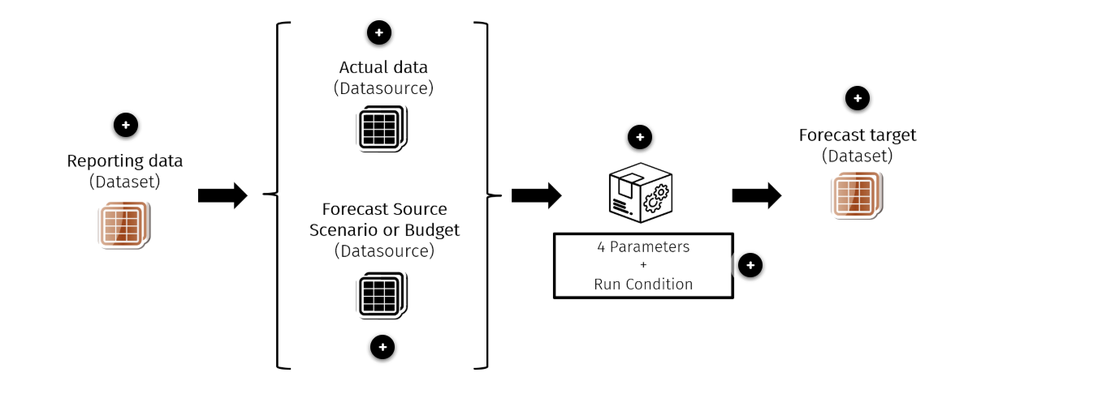
Reporting data
Contains the data to be retrieved.
Actual Data
Datasource used to retrieve and filter actual data.
Forecast Source Scenario
Datasource used to retrieve the previous Forecast Scenario or Budget.
DTP
DTP involves executing operations based on the selected model, applied through a specified run condition and parametric filters.

It derived from lists in the Dictionaries within the analytical workspace.
- Actual Scenario
- First Forecast Period
- Forecast Source Scenario
- Forecast model
Forecast target
Standard dataset used to store the results.

NOTE: As mentioned in the previous module, you can implement two forecasting models. For this business case, you are using the Hold to-Year forecast model, which follows the logic of business trends, tracking data as it is.

Implementation details
To implement a dynamic forecast prefill through parametric selection in CCH Tagetik, you will need to use the following three components:
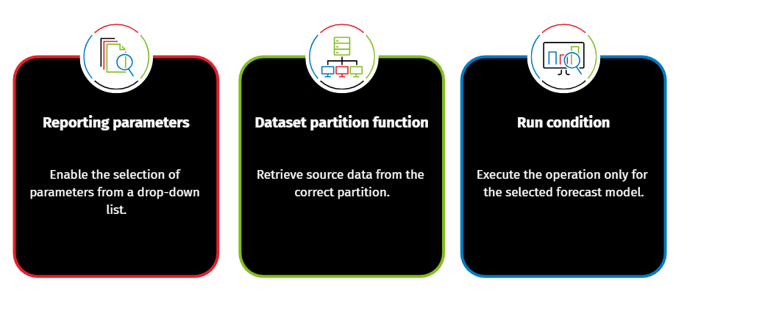

Reporting Parameters
You need parameters to dynamically select and filter information for data processing.
How can you implement these parameters?

The reporting parameters are set in the Excel add-in and can be recalled in Datasources and DTP operations. You define them using the Definition icon on the Excel ribbon bar. When you click on the Definition icon, a pop-up window appears where you can insert, modify, delete, or duplicate parameters. The four defined parameters are set with data type Dictionary, to be able to select the value through a drop-down list that shows the elements of the Dictionary.

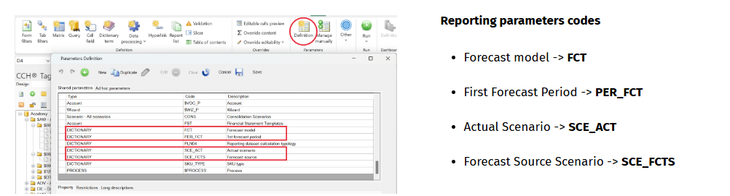

NOTE: These parameters will be preceded by the @ symbol, for example @SCE_ACT, @FCT, when recalled on the Datasources or during the DTP operation.

Dataset partition

Given the nature of the data involved in the forecast pre-population will likely be saved in datasets partitioned by business cycle.
It is crucial to be able to read the data accurately by referencing the appropriate partition without hard-coding the table name.
The proposed business case uses two datasources, Actual (2058ACT) and Forecast source data (2058BDG), both reading from dataset 80 – Reporting data partitions. The simplified environment of this business case includes only two partitions. The image below provides detailed information regarding the partition names.
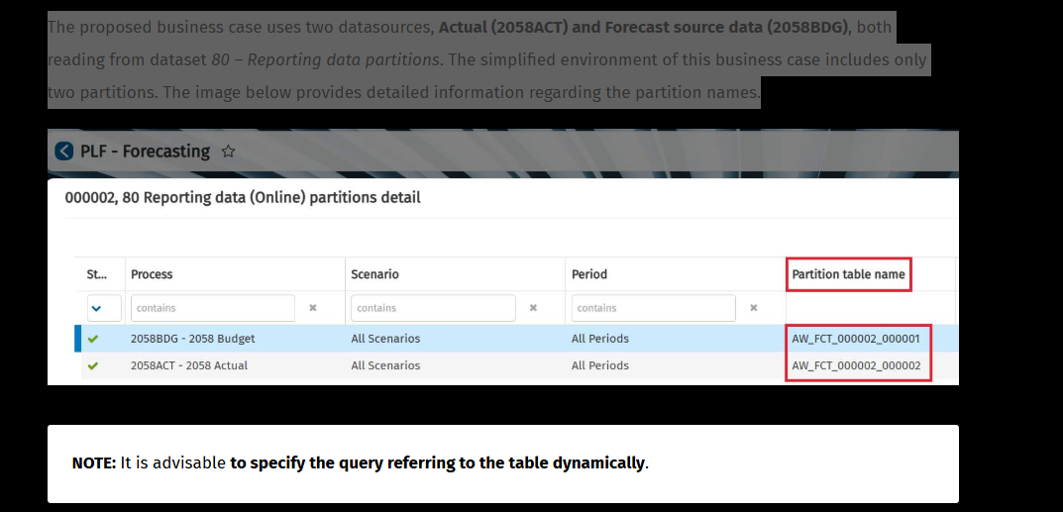

How do you retrieve the data?
You retrieve the data by specifying a dataset partition function in the Datasource query.
The query will read and display data from partitions, based on the parameters selected when the DTP was launched. To do this, you can take advantage of the dataset partition function.
The inputs to specify the dataset partition function are the following:
ccording to the partition policy of the dataset, you are required to specify only the necessary codes relevant to your purpose.
The image below illustrates an example in which all codes are specified. Dimensional attributes or parameters may be used to define the inputs according to the context.
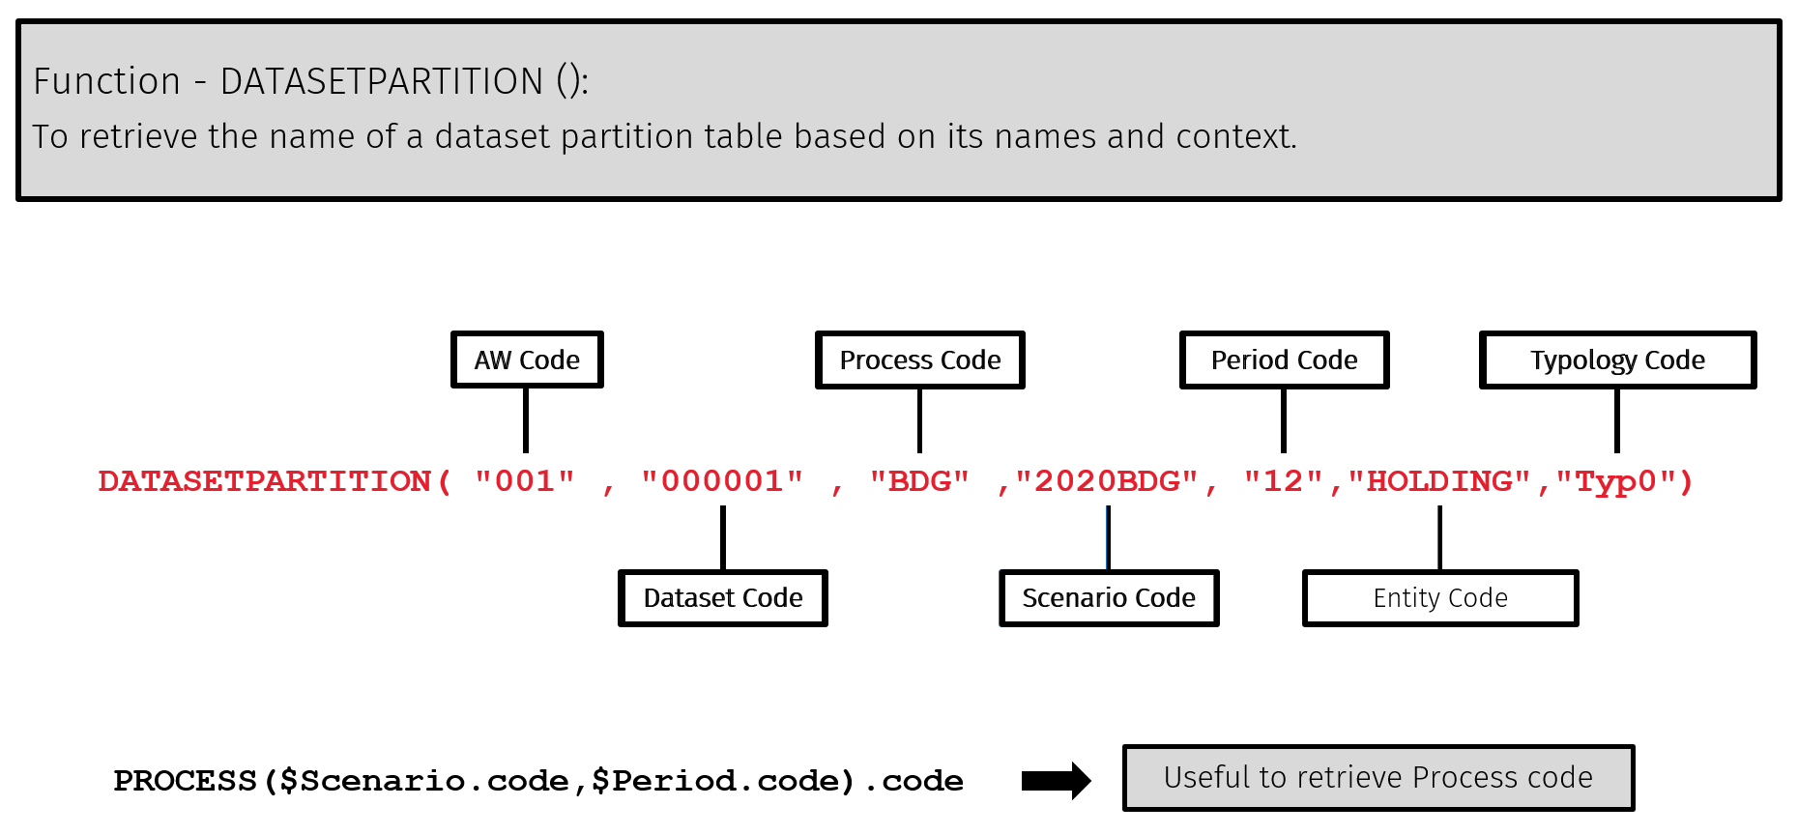
Business case function
In the business case, the function of the Forecast source will be as follows:
$Datasetpartition (“FCT”,”000002”, PROCESS(@SCE_FCTS.code,”01”),@SCE_FCTS.code,”01”)
Refer to the table below to understand the meaning of each part of the functio
Code | Meaning
FCT | It is the Analytical Workspace code.
000002 | It is the Dataset code.
SCE_FCTS.code | It represents the code of the Forecast source scenario selection defined through the parameter.
01 | It is the Period code of a month that always exists and must be present.
NOTE: It is assumed that the dataset is partitioned by business cycle and the number of cycles is single.
Target scenario selection
The target scenario is determined by the context, depending on the scenario associated with the selected forecast process, by following the steps below:
- 1
Read Data from Source Tables: Retrieve information of actual or forecast source scenarios in the relative field.
- 2
Pre-fill the Target Scenario: Substitute the scenario code using the dimensional attributes $Scenario.code retrieved from the context.
The benefit of substituting the scenario code is that no additional transformations in DTP are needed to get the target scenario.
Query syntax
For an overview of the syntax used in datasource query to retrieve forecast source data, refer to the boxes below:
Reporting Parameter
Parameter
@PARAMETER
Syntax
From ${DATASETPARTITION("FCT","000002",PROCESS(@SCE_FCTS.code,"01").code,@SCE_FCTS.code,"01")}
Dimension attribute
Parameter
$Scenario.code
Syntax
Select ${$Scenario.code} as SCENARIO, PERIOD, ENTITY, ACCOUNT, AMOUNT

DTP and run condition
The DTP activity to pre-fill forecast scenario is performed by using insert operations with the relative filters. The filters and run condition are applied to process only the data for the selected model.
e example of the business case, you need to set up two insert operations: one for the Actual data and one for the Forecast Source Scenario. The filters to be applied are relative to the dynamic parameters previously set, which will provide you with the data for the selected version and period.

Assuming that the first forecast period is April, the first insert operation for the actual data retrieves the data up to March, and the second insert operation retrieves the data for the month of April and the following, up to the last period of the scenario.
To distinguish between the actual periods and forecast source periods, the source filter must recall the Reporting parameter Period and will be set to minor, equal or major based on the desired month, with the following syntax:
PERIOD<${@PER_FCT.code} for Actual data, to read only periods before the first forecast period.
PERIOD>=${@PER_FCT.code} for Forecast data, to read only from the first forecast period onwards.
Additionally, the second operation requires a Run condition (a logical condition to determine whether to execute the operation) for performing the forecast model, Hold to-year. You will be able to insert the source forecast data with this operation only if the model you select through the parameter is the Hold to-year model. In the image below, you can see the forecast model specified in the Run Condition.
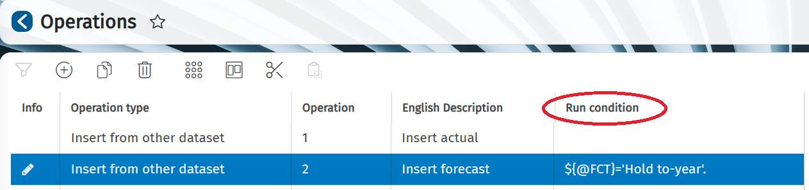

When you run the DTP, you need to specify all the parameters you have set earlier, as per below:
- •
First Forecast Period (Period list)
- •
Actual Scenario
- •
Forecast model
- •
Forecast Source (Scenario)

Forecast Demo : implementing a forecast model using the AIH

Knowledge check

Forecasting additional options
In this module, you will learn:
- How to implement additional forecasting requirements
- How the rolling forecast works

Additional forecasting requirements and options
here are several additional options available for running a forecast, particularly if you have specific requirements to address. The additional possible options include:

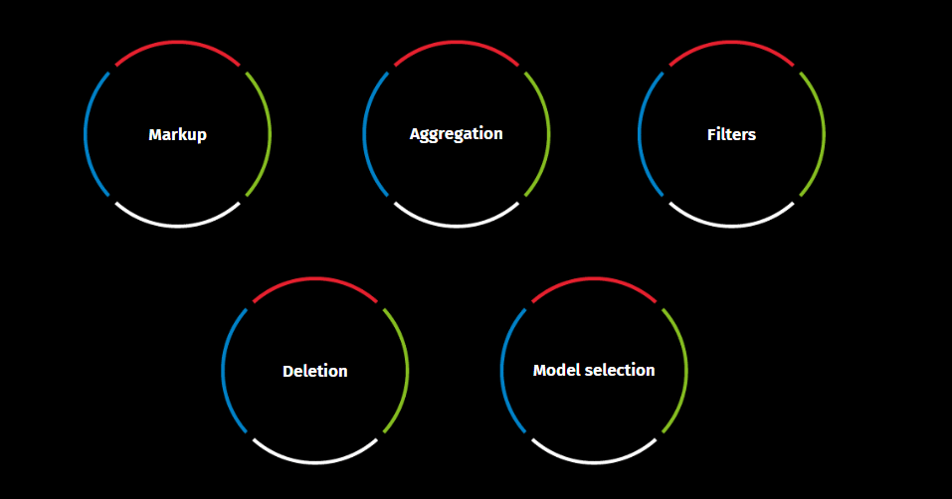
Markup
A markup is a numerical coefficient that you can apply to forecast data. You can insert it as a parameter in a Datasource or in the DTP operation.
Imagine you have to apply a 10% increase from April onwards in your target forecast scenario. How do you do it?
- In the Excel add-in, define a Markup parameter with data type Numeric.
- Apply the Markup parameter to multiply the amount of the forecast data, for example AMOUNT*(1+Markup parameter).
  - In the Datasource, you need to write it in the query.
  - In the DTP, you will apply it in the matching fields of the insert operation.
This 10% will be added to all forecast numbers, as per the image below.

This 10% will be added to all forecast numbers, as per the image below.
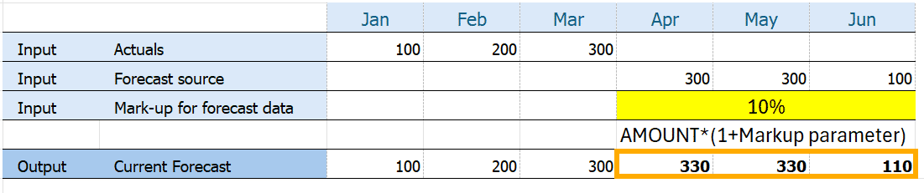
- Aggregation
You can use it when you want to reduce the level of detail of the forecast, or you need actual and forecast data having different levels of detail to match.
The tool used for aggregation is typically a lookup table, which can be:
  - Specified in a reference dataset
  - Recalled from a hierarchy
For example, consider that you have the actual data by Stock Keeping Unit (SKU) and the budget data by product family (an aggregation of SKU). To create a forecast, it is convenient to have the same level of detail, hence it will be appropriate to aggregate the actual data by product family.

Filters
Filters can be used to process only a subset of data. A filter can identify a dimensional element or a hierarchy node and is selected using the dimensional parameters.
Suppose you need to populate a forecast for a specific entity. You will select the entity through a dimensional parameter during runtime. The filter will process only the data specified by the Entity dimensional parameter within the Source filter of the DTP insert operation. Consequently, the target forecast will include only the data relating to the selected entity.
See below an example of a source filter specification assuming:
- The dataset field is coded as ENTITY
- The selection through the default dimensional parameter is defined as: $AZI_P (flat list of entities)
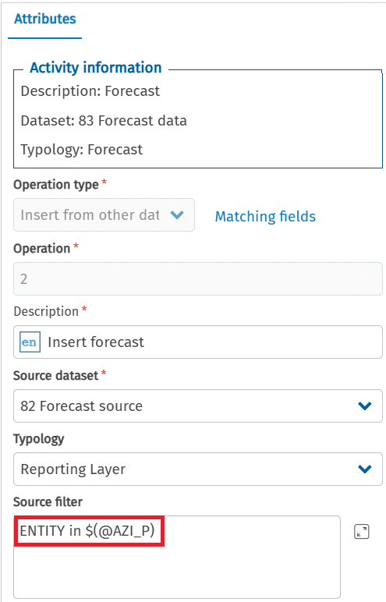

Deletion
In case you need to preserve data present in the target scenario from deletion, you can specify a deletion policy in the Reporting Layer filter of the DTP activity.
When your target forecast scenario has been populated with DTP results and subsequently modified via a Data Entry form, you may wish to recreate the forecast while retaining the manual updates. To achieve this, you can write the deletion policy within the Reporting Layer filter (as shown below). By doing so, the data update in the Reporting Layer will incorporate the information processed through DTP, without removing data input from other origins, such as data entry.
NOTE: The origin field in the table is identified in the column “PROVENIENZA”.
OTE: The origin field in the table is identified in the column “PROVENIENZA”.
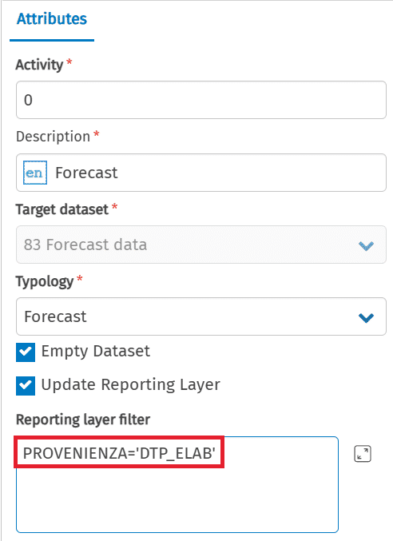

Forecast model selection
The selection and application of the forecast model are determined by the reporting parameters set during the launch of the DTP. Within the DTP, the forecast model is specified as a Run condition, ensuring that only the operations relevant to the chosen model are executed.
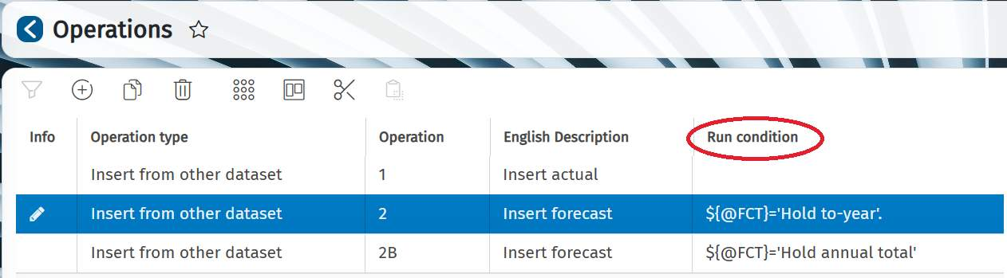

Rolling forecast overview

In the previous module, Budgeting, Planning and Forecasting 1 - Business case Forecasting, you have seen an example of the static forecast. Now you will see an overview of the rolling forecast.

Rolling forecasts enable companies to respond to market trends by continuously revising the forecasts' time horizon.
The rolling forecast is a dynamic report that uses historical data to continuously predict future numbers over a period of time, while static forecasts rely on historical data up to the end of the year.
Because of their responsive and flexible nature, rolling forecasts help companies respond more quickly to changing market conditions. When used effectively, rolling forecasts can help you identify performance gaps, shorten planning cycles and make the best decision for your bottom line.

Static forecasts provide estimates for a fixed time frame, typically till year-end, while Rolling forecasts continuously update by dropping the previous month and automatically forecasting the next month. This approach involves ongoing planning over a time horizon, using the most recent numbers and time frames. To develop a rolling forecast you need to use: actual data, forecast source scenario (within the same year), and forecast beyond the year.
Rolling forecast components
The scheme below shows the components involved in the workflow. Click on the buttons over the image to discover more about them.
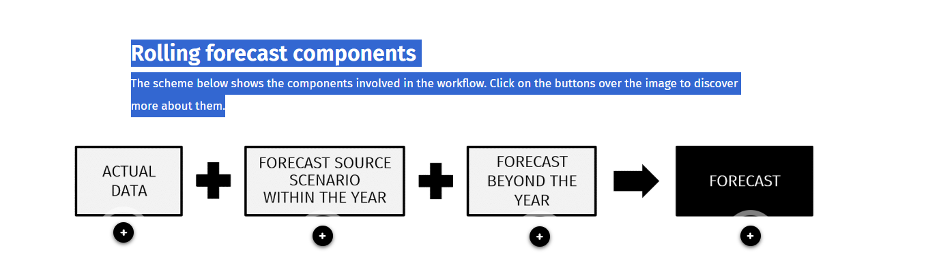

Actual Data scenario
Datasource used to retrieve and filter actual data.

Forecast source scenario (within the same year)
Datasource used to retrieve the previous Forecast Scenario or Budget.
Forecast beyond the year
The future Forecast Scenario or Budget to be populated with the use of various methods including Machine learning.
Forecast
Target Dataset designated to store the results.

Rolling Forecast set up

Rolling forecast Setup
Lesson 4 of 6
To set up a rolling forecast, it is important to note that the scenario extends into the following year, requiring the encoding of the scenario. Generally, the coding is composed as follows:
2041RF_02_40
Refer to the table below to understand the meaning of each part of the code.
Code | Meaning
2041RF | The information for the fiscal year you are forecasting
02 | The month in which you are currently forecasting
40 | The year in which you are currently forecasting

This coding is self-explanatory, by looking at its parts you can figure out the forecast horizon taken into consideration. It is a key aspect of tracking and using the most current version, considering a rolling forecast of 12 months.
Visualization of a rolling forecast
If you are in the year 2040, you can examine both actual and forecast data scenarios. The forecasting process for February and March 2040 is illustrated below, starting with the actual data available first for January and then for February, along with a forecast for the other months. This process is conducted monthly during 2040 and considering the 12-month rolling forecast, it extends into the following year. It is a cyclical process that is continually updated.
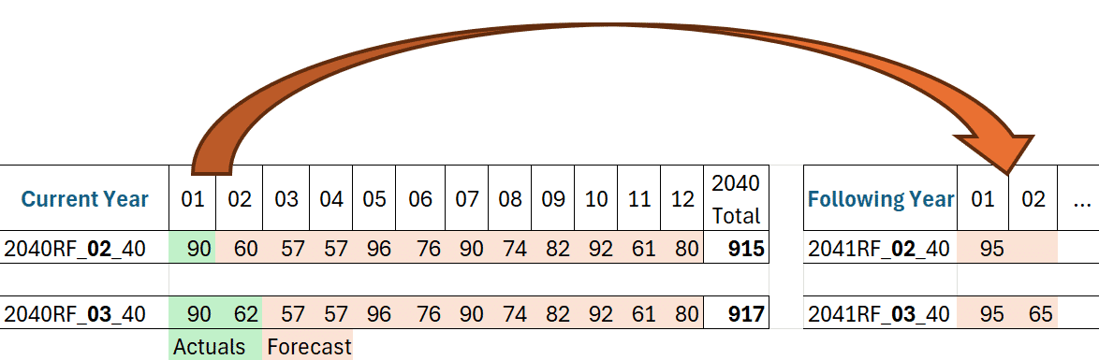
Pre-populating forecast periods beyond the current year require a well-structured approach, as additional complexities that must be considered.
How many scenarios and periods to manage?
Which model to apply?
What sources will fill the scenarios and periods beyond the year?
To fill the scenarios beyond the year you can use: Excel formulas, DTP, and predictive intelligence. Machine learning allows you to use statistics and time series to make projections and forecasts.

Takeways

Statistical Forecasting
There are two main approaches to statistical forecasting: Time Series forecasting for short-term tactical planning and Model Based forecasting for long-term strategic planning. Each approach has its own requirements and outcomes, see below the table:
 | Time series forecasting | Model based forecasting
Purposes | Tactical, determining seasonal patterns | Strategic, accounting changes in business
Requirements | Historical data | Management insight
Results | Short-term adjustments | Changes in business practices
Uses | Demand and production planning and inventory management | Marketing, resource allocation, business optimization and business plans comparisons
Implementations | Predictive intelligence | Built-in forecast models (FW)  Custom model (AIH)

